Objective: To review the definition, impact, and response procedures for abusive conduct in the workplace

“Abusive conduct” means conduct of an employer or employee in the workplace, with malice, that a reasonable person would find hostile, offensive, and unrelated to an employer’s legitimate business interests.  Abusive conduct may include repeated infliction of verbal abuse, such as the use of derogatory remarks, insults, and epithets, verbal or physical conduct that a reasonable person would find threatening, intimidating, or humiliating, or the gratuitous sabotage or undermining of a person’s work performance.  A single act shall not constitute abusive conduct, unless especially severe and egregious. |  | Definition from California AB 2053, section 12950.1.(g)(2)
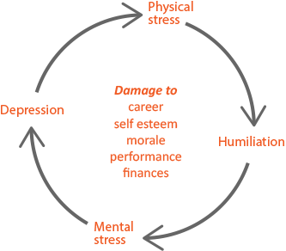
Harm to the Individual:
Abusive conduct in the workplace can threaten an individual’s mental, physical, and financial well-being.

Abusive conduct is often perpetrated by management-level employees, and subjects are often reluctant to report their supervisors. Feelings of isolation and humiliation may threaten their self-esteem and the ability to advance their careers.

Subjects often feel trapped in patterns of abusive conduct and are prone to a vicious cycle of health problems brought on by depression and anxiety.

Harm to the Organization
Abusive conduct often creates a hostile environment where talented and productive employees are demoralized and marginalized.

People who are targets of abusive conduct are often isolated from the team and experience a diminished pride of ownership for their work. A hostile work environment can lead to significant economic losses from chronic absenteeism, employee health issues, and worker turnover.

If abusive behavior is not addressed swiftly, the eventual expense to the organization can include investigation and opportunity costs and costs associated with disciplinary action.
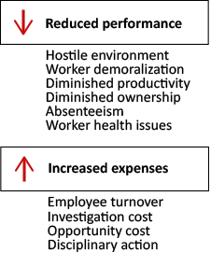
Prevention Program
An effective prevention program:
- Defines abusive conduct.
- Establishes a prevention and correction program with mechanisms for complaints and concerns.
- Provides training and awareness activities.
- Documents patterns of abusive behavior.
- Responds to incidents and complaints swiftly. This typically includes an investigation and, where indicated by the investigation, appropriate and effective disciplinary action.
- Offers counseling and treatment resources to targets of abuse.

Reporting Abusive Conduct
You need to know your company's complaint procedure and who to inform, such as your HR representative, your manager, or both. Also, be prepared to provide, at a minimum, the following information:
- The name of the person being subjected to abusive conduct
- The name of the alleged abuser
- The time and date of the incidents
- The locations where the incidents occurred
- Names of any witnesses
- Descriptions of the incidents
This form documents that the training specified above was presented to the listed participants. By signing below, each participant acknowledges receiving this training.

Organization: Date: ________________________

Trainer: Trainer’s Signature: _____

Class Participants:

Name: ____ _______ Signature: ___________
Name: ____ _______ Signature: ___________
Name: ____ _______ Signature: ___________
Name: ____ _______ Signature: ___________
Name: ____ _______ Signature: ___________
Name: ____ _______ Signature: ___________
Name: ____ _______ Signature: ___________
Name: ____ _______ Signature: ___________
Name: ____ _______ Signature: ___________
Name: ____ _______ Signature: ___________
Name: ____ _______ Signature: ___________
Name: ____ _______ Signature: ___________
Name: ____ _______ Signature: ___________
Name: ____ _______ Signature: ___________
Name: ____ _______ Signature: ___________
Name: ____ _______ Signature: ___________

