Objective: To raise awareness of common hazards associated with compressed gas cylinders

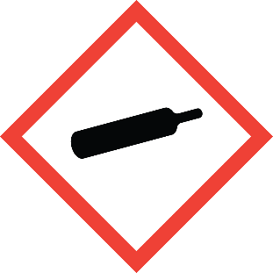
Compressed gas cylinders are hazardous due to the high pressure of their contents as well as the potential hazards of the contents themselves. Before working with cylinders, familiarize yourself with the characteristics of their contents and learn proper cylinder handling procedures.
Pressure
The contents of compressed gas cylinders are under extreme pressures, often hundreds and even thousands of pounds per square inch (psi). A sudden uncontrolled decompression (e.g., due to a cylinder being punctured or a valve breaking) can turn the cylinder into a missile with the potential to cause severe injury and property damage.
Temperature
Certain gases must be stored cryogenically in liquid state, which require specialized insulated cylinders. Contact with cryogenic liquids (or improperly-insulated vessels containing them) can cause frostbite or asphyxiation. Additionally, if released, cryogenic liquids can become toxic upon evaporation back into their gaseous state.
Chemical Hazards
The contents of cylinders may have their own hazardous characteristics, such as the following:
• Flammable
• Toxic
• Corrosive
• Oxidizing
• Asphyxiating
This form documents that the training specified above was presented to the listed participants. By signing below, each participant acknowledges receiving this training.

Organization: Date:

Trainer: Trainer’s Signature:

Class Participants:

Name: Signature:

Name: Signature:

Name: Signature:

Name: Signature:

Name: Signature:

Name: Signature:

Name: Signature:

Name: Signature:

Name: Signature:

Name: Signature:

Name: Signature:

Name: Signature:

Name: Signature:

Name: Signature:

Name: Signature:

Name: Signature:

