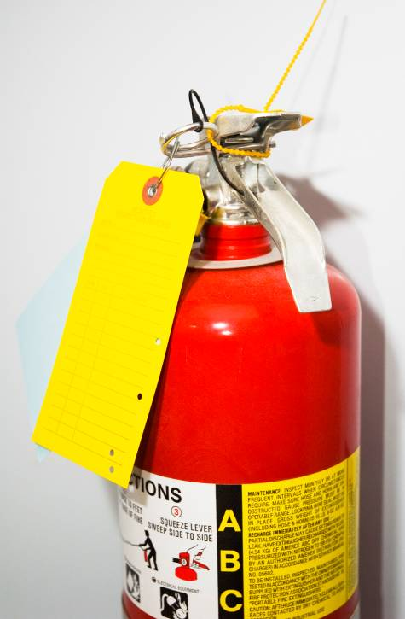
In Case of Fire: Should staff evacuate the building or be prepared to fight small fires?

Fire is the most common type of emergency for which organizations must plan. One important decision to make when writing your Emergency Action Plan is whether or not staff will fight small fires with portable fire extinguishers or simply evacuate the building.

A small fire can often be put out quickly by trained staff using a portable fire extinguisher. However, to do this safely, the staff must be trained and understand the use and limitation of portable fire extinguishers, and the hazards associated with fighting fires.

Emergency Action Plans that authorize some or all of the staff to fight fires must, therefore, require considerably more training and resources than those that only stipulate building evacuation.

Choosing to evacuate the workplace rather than to authorize fire-fighting will most effectively minimize the potential for fire-related injuries. Other factors, however, such as the availability of a public fire department and the vulnerability of exit routes, enter into the decision.

Employee Evacuation

All staff who is not authorized to fight fires must evacuate the building immediately upon the triggering of a fire alarm - they must do so automatically, no questions asked, no exceptions.

The Emergency Action Plan must specify the alarm method, how the staff should exit the building, where they should go, and where and to whom they should report after they have evacuated safely. Before the evacuation can be considered complete, management must be able to account for all staff.

Risk Assessment and Fire Fighting

If any staff member is allowed to remain inside and fight a small fire with a portable fire extinguisher, the Emergency Action Plan must include thorough, annual training on proper fire-danger evaluation and proper fire extinguisher use.

Note: All fire extinguishers kept on the premises must undergo annual inspection and maintenance even if no staff is authorized to use them. They should also be checked monthly to assure they are in their proper locations, charged, and in a “ready-to-use” state. Fire extinguishers should be located along normal paths of travel and accessible in an emergency...“Think Proactively” and make sure they are placed where needed. If your organization uses or stores flammable liquids you will need more fire extinguishers (every 50 feet) than if you only have normal combustibles (every 75 feet). Local and state regulations vary regarding the required number and location of fire extinguishers based on your organization’s occupancy or activities, so check local codes. Always error on the safe-side by assuring adequate numbers and that all areas are covered.

Prior to fighting any particular fire with a portable fire extinguisher, a risk assessment must be done to evaluate such things as the fire’s size, evacuation routes, hazards in the area such as flammables and combustibles, and the atmosphere in the vicinity of the fire.

Portable fire extinguishers serve two functions: they control or extinguish small fires and they protect evacuation routes that fires may block directly or indirectly with smoke or burning materials.

To extinguish a fire with a portable extinguisher a person must have immediate access to the extinguisher, know the types of fires and needed extinguishers, know how to actuate the unit, and know how to apply the extinguishing agent effectively.

Attempting to extinguish even a small fire carries some risk. A fire can increase in size and intensity in seconds and possibly create a hazardous atmosphere or block the evacuation route of the fire fighter. In addition, portable fire extinguishers contain a limited amount of extinguishing agent and can be discharged in a matter of seconds. Therefore, individuals should only attempt to extinguish very small fires.
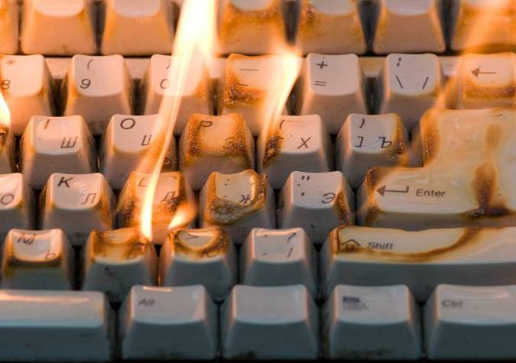
Fire Size Evaluation

Stay and fight the fire?
Yes, if: The fire is limited to the original material ignited, is contained (such as in a waste basket), and is not higher than the firefighter's head.
No, if: The fire involves flammable solvents or hazardous materials, has spread over more than 60 square feet, is partially hidden behind a wall or ceiling, cannot be reached from a standing position, or poses other serious hazards.

Air Quality Evaluation

Stay and fight the fire?
Yes, if: The fire has not and will not deplete the oxygen in the room and is producing only a small amount of smoke. Smoke may be accumulating on the ceiling, but visibility is good and no respiratory protection is required.
No, if: Smoke is quickly filling the room decreasing visibility, or creating a respiratory hazard in which the fire cannot be fought without respiratory protection.

Room Temperature Evaluation

Stay and fight the fire?
Yes, if: Heat is being generated, but the room temperature is not increasing and no special personal protective equipment is required.
No, if: The radiated heat is easily felt on exposed skin making it difficult to approach within the effective range of the extinguisher.

Evacuation Route Evaluation

Stay and fight the fire?
Yes, if: There is a clear evacuation route behind the firefighter as he fights the fire.
No, if: The fire is not contained and fire, heat, or smoke may quickly block the evacuation route.

This form documents that the training specified above was presented to the listed participants. By signing below, each participant acknowledges receiving this training.

Organization: Date:

Trainer: Trainer’s Signature:

Class Participants:

Name: Signature:

Name: Signature:

Name: Signature:

Name: Signature:

Name: Signature:

Name: Signature:

Name: Signature:

Name: Signature:

Name: Signature:

Name: Signature:

Name: Signature:

Name: Signature:

Name: Signature:

Name: Signature:

Name: Signature:

Name: Signature:

