By following a few basic guidelines, you can prevent slips, trips, and falls.

Slipping on a wet spot on the floor, tripping over an object in the walkway, or falling from a ladder – such accidents happen more often than we realize. They can also result in severe injuries.

Neatness counts

It is everyone’s responsibility to keep work areas clean and safe. During the course of the work day you might find yourself tripping over or walking around boxes, electrical cords, or tools in an area that was previously clear. This makes it difficult for you to do your work safely and efficiently.

If you see such a problem, correct it right away because it might cause an injury to the next person who comes along – or to you if you pass that way again. Everyone should watch for, report, and, when possible, correct slip, trip, and fall hazards.
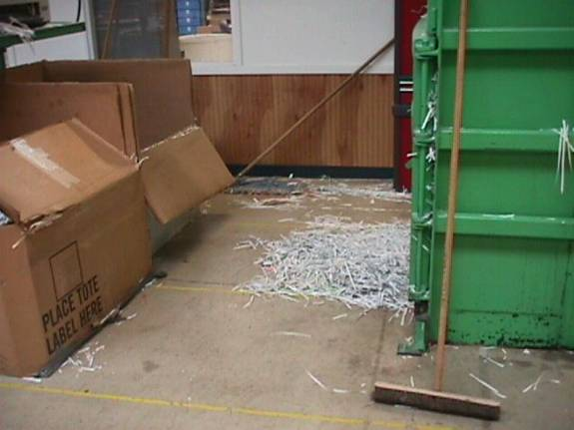
Housekeeping

Good housekeeping is an integral part of every organization’s safe work policy. Walkways and workstation floors must be kept free of clutter and debris. Accidentally spilled liquids and other slippery materials must be cleaned up immediately.

Housekeeping is not just a rainy-day task or a once-a-month chore; it is a job that must be done hour by hour.

Accident prevention fundamentals

- Clearly mark walkways through busy areas with paint or railings. Ensure that walkways are sufficiently wide and well lit. Provide enough light in all work areas.
- Do not allow carpets or mats to bunch up or fold and create a trip hazard.
- All walking surfaces must be free of irregularities such as holes and depressions. Repair such floor damage immediately.
- Keep floors clean and dry. If the work results in wet floors, install adequate drainage and cover floors with one of the many available styles of non-skid surfacing. Workers must wear slip-resistant footwear in damp areas.
- Do not run in the workplace.
- Keep stairways and ramps in good repair and free of obstructions. Install non-skid surfacing on the stair treads. Ensure that handrails are properly installed and extend past the top and bottom steps. Mark the first and last steps clearly, such as with yellow stripes.

Incident investigation

If a slip, trip, or fall incident does occur, the employer must conduct a complete investigation into the cause(s). Document all aspects the incident and investigation.

Was there an unsafe act? Was there an unsafe condition? Determine the causes, identify and implement solutions, and follow-up to ensure that the situation that caused the incident no longer exists.

This form documents that the training specified above was presented to the listed participants. By signing below, each participant acknowledges receiving this training.

Organization:

Trainer: Trainer’s Signature:

Class Participants:

Name: Signature: Date:

Name: Signature: Date:

Name: Signature: Date:

Name: Signature: Date:

Name: Signature: Date:

Name: Signature: Date:

Name: Signature: Date:

Name: Signature: Date:

Name: Signature: Date:

Name: Signature: Date:

Name: Signature: Date:

Name: Signature: Date:

Name: Signature: Date:

Name: Signature: Date:

Name: Signature: Date:

Name: Signature: Date:

Name: Signature: Date:

Remember to Load Your Completed Trainings into the Training Track Application of Your Platform.

