Cranes are used in almost every industry setting because of their ability to do large amounts of work by lifting and moving heavy items. When moving large and heavy items, cranes have a large amount of potential energy suspended in the work environment. If failure or misuse occurs, it can cause property damage, injuries, and fatalities. Always follow safe material handling practices when using cranes and slings.

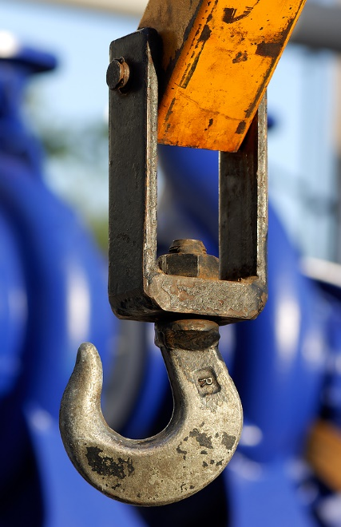
Requirements Prior to Use:
- All cranes and slings must have manufacturer weight restrictions clearly labeled and visible from the ground. Weight restrictions must be followed when using cranes and slings.
- Only those people trained and certified in safe crane operations are permitted to operate the crane.
- Always conduct an inspection of the cranes, slings, and hooks prior to use: look for hydraulic leaks and any wear and tear, twisting or deformed, cracked, or corroded components.
- Any lifting equipment identified as defective must be taken out of service to ensure that no one else uses the equipment until it is repaired or replaced.
Safe Material Handling Practices
- Never lift a load that exceeds the weight restrictions of the crane, sling, or hook.
- Ensure that chains, ropes, and slings are not twisted.
- Go over path of travel to ensure there are no hazards or snag points, and notify employees in the area of the intended path of travel.
- Ensure hoist is directly over the load’s center of gravity, for stability.
- Move the load close to the ground while avoiding all other equipment, materials, and personnel.
- Move the load slowly, and avoid sudden stops or jerking movements.
- Never leave the controls while the load is suspended.
- Never use the crane to drag or pull a load sideways.
- Never allow any person on or under a load.
- When you are done using the crane, return the head to the top of the crane, and place all hooks and slings back in a safe storage location.
This form documents that the training specified above was presented to the listed participants. By signing below, each participant acknowledges receiving this training.

Organization: Date:

Trainer: Trainer’s Signature:

Class Participants:

Name: Signature:

Name: Signature:

Name: Signature:

Name: Signature:

Name: Signature:

Name: Signature:

Name: Signature:

Name: Signature:

Name: Signature:

Name: Signature:

Name: Signature:

Name: Signature:

Name: Signature:

Name: Signature:

Name: Signature:

Name: Signature:

