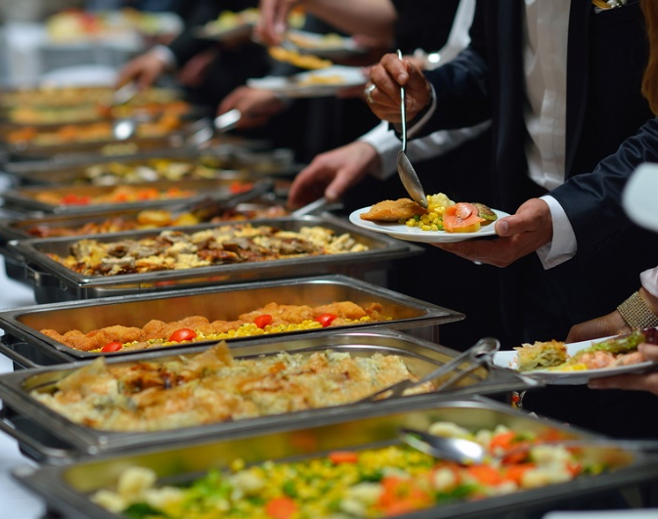
Potlucks and buffets carry a high risk for foodborne illness because bacteria thrive in food that is left out for long periods of time at room temperature. The danger zone for bacterial growth is between 40˚ and 140˚F. The maximum amount of time that food can stay in this range before becoming dangerous is two hours, and potlucks and buffets easily last longer.
Sanitary practices, avoidance of cross-contamination, and temperature control guard against bacteria. Take care while preparing, storing, and serving food.

Types of bacteria:
- Staphylococcus aureus: Commonly called “staph”, these bacteria are found on human skin and inside noses, throats, and infected cuts and pimples. They can contaminate food during preparation, and they thrive when food is left out at room temperature. This type of bacteria produces a toxin that cannot be destroyed by heat.
- Clostridium perfringens: Also called “cafeteria germs,” these are often found in large servings of food that are allowed to reach danger zone temperatures.
- Listeria monocytogenes: If food has been contaminated by these bacteria, they can multiply and produce toxins even in temperatures below 40˚F. This type of bacteria is commonly found in dairy products, such as un-pasteurized milk and cheese.
- Salmonella: These bacteria are found in poultry, eggs, raw milk, and raw milk products. It can be introduced into food during food preparation or from consuming raw or unpasteurized products.
- Escherichia coli (E. coli): E. coli exposure may be the result of cross contamination from raw meat and produce. There are various strains of E. coli that result in a range of health symptoms including diarrhea and other intestinal problems.
Avoiding contamination:
- Always wash hands before handling or preparing food.
- Keep areas, utensils, and platters used for food preparation and serving clean.
- To protect against staph bacteria, do not prepare food if you have an infection of the skin, eyes, or nose.
- Do not reuse serving platters without first cleaning them.
- To guard against Listeria monocytogenes, observe sell-by and use-by dates on pre-packaged foods.
Temperature control:
- Food preparation:
- Food must reach the proper internal temperatures while cooking.
- Cool food quickly and evenly when storing. Put the cooked food into a shallow container and place in the refrigerator or freezer.
- Reheat foods to 165˚F.
- Serving practices:
- Keep hot foods at 140˚F or above by using chafing dishes, slow cookers, or warming plates.
- Keep cold foods cold by putting the serving bowl or platter in an ice bath, and replace the ice as needed.
- To limit the time food is at room temperature, put out small serving sizes of the food, and keep the rest in either the oven or refrigerator until it is ready to serve.
- Track the time that foods have been on the buffet table at room temperature, and discard any food that has sat out longer than two hours.

If foodborne illness is suspected, contact a healthcare
professional immediately and describe the symptoms.

This form documents that the training specified above was presented to the listed participants. By signing below, each participant acknowledges receiving this training.

Organization: Date:

Trainer: Trainer’s Signature:

Class Participants:

Name: Signature:

Name: Signature:

Name: Signature:

Name: Signature:

Name: Signature:

Name: Signature:

Name: Signature:

Name: Signature:

Name: Signature:

Name: Signature:

Name: Signature:

Name: Signature:

Name: Signature:

Name: Signature:

Name: Signature:

Name: Signature:

