Objective: To assure that proper methods of handling and storage of compressed gas cylinders are understood and utilized by all employees

Compressed gas cylinders require care during handling, transportation, and storage to minimize the chances of their contents escaping. Follow these best practices to assure that you, your coworkers, and your worksite will remain safe.
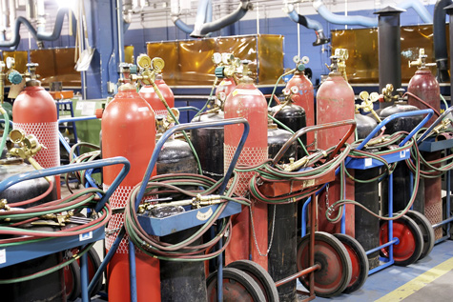
Handling
- Complete all required training before handling or using compressed gas cylinders.
- Keep cylinders secured in an upright position at all times, including during use.
- Do not strike cylinders against other cylinders or surfaces.
- Do not expose cylinders to electrical circuits, use a cylinder as a ground when welding with electricity, or strike an electrode against a cylinder when striking an arc.
- Never position cylinders near ignition sources.
- Never use cylinders for anything other than the intended use. For example, do not use them as rollers or supports.
- Do not refill cylinders.
Hazard Communication
- Familiarize yourself with any labels or signage found in storage or work areas or on cylinders that communicates hazards.
- Assure that cylinders bear proper GHS-compliant labels that identify contents and classify hazards. Do not use cylinders that are not clearly marked with their contents or hazards.

Transportation
Prior to moving cylinders:
- Do not move cylinders without proper authorization.
- Confirm the cylinders’ contents and review the SDSs for handling requirements.
- Close valves, bleed lines, remove regulators, and replace valve safety caps before moving.
- Assure that your planned route is clear of obstacles.
While moving cylinders:
- Use a cart designed for this purpose.
- Use a chain to secure them to the cart.
- Stay on designated pathways.
- Never lay cylinders on their sides or roll them by hand.
If lifting cylinders:
- Assure that appropriate lifting attachments are used and cylinders are properly secured.
- Do not lift cylinders by their caps or with magnets.
- Do not drop cylinders from any height.
Storage
- Keep storage areas cool, dry, well-ventilated, and protected from recognizable hazards.
- If storing cylinders outdoors, make sure they are properly protected from direct sunlight and extreme hot and cold temperatures as necessary.
- Limit access to authorized and trained persons.
- Position storage areas at least 20 feet away from stairs, aisles, elevators, and combustible and flammable materials.
- Assure that cylinders with incompatible contents (such as oxidizers and flammables) separated by at least 20 feet or an approved fire-resistant barrier.
- Never store cylinders in in confined spaces.
This form documents that the training specified above was presented to the listed participants. By signing below, each participant acknowledges receiving this training.

Organization: Date:

Trainer: Trainer’s Signature:

Class Participants:

Name: Signature:

Name: Signature:

Name: Signature:

Name: Signature:

Name: Signature:

Name: Signature:

Name: Signature:

Name: Signature:

Name: Signature:

Name: Signature:

Name: Signature:

Name: Signature:

Name: Signature:

Name: Signature:

Name: Signature:

Name: Signature:

