Objective: To assure that employees understand the proper actions to take in the event of a vehicular accident

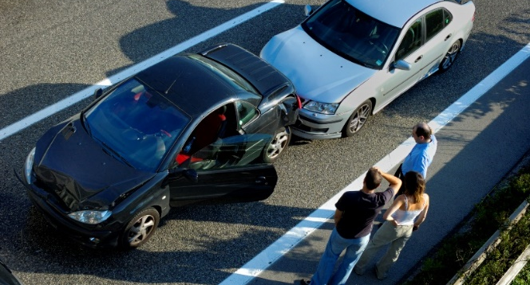
Know what to do in the event of an accident
so that you do not make the situation worse.
If you are prepared, your actions will be
almost automatic.
- Turn the vehicle off. If you are in an
accident, turn off the ignition and try your
best to stay off of the road.
- Stay at the scene of the accident.
- Stay until you have been authorized to leave the scene. This might be after you have exchanged insurance information with the other party, or it might be when the police give you permission to leave.
- The exception may be if you need medical attention or leave to get help.
- If you need to leave the scene, leave a note in a conspicuous place on your vehicle with your contact information.
- Provide aid to others. If you are physically able, provide assistance to others involved in the accident to the level you are trained.
- Do not move injured victims. Never move injured victims unless it is absolutely necessary to get them away from fire or passing traffic. Moving them can easily make their conditions worse, especially if they have head or neck injuries. If there are injuries, call 911 immediately. Give first aid, but only to the level you are trained and confident in administering.
- Call the appropriate people. Call the police, your home, or office immediately.
- Make sure to report the accident. No matter who is responsible, every vehicular accident must be reported at once. It is a criminal offense to leave the scene of any accident before identifying yourself.
- Collect information. Get the license numbers of all vehicles involved and the names and addresses of all drivers and passengers. If there has been any property damage, get the name and address of the owner or owners. List the companies that insure the property and vehicles. Try to get the names and addresses of anyone at the scene, whether they actually saw the accident or not.
- Do not argue or discuss fault. In the emotionally stressful situation of an accident, people are often unable to stay rational when discussing fault. Arguments will only be counterproductive and prevent you from getting the facts down on paper.
- Search for the owner. If the accident involves an unattended vehicle (such as a parked car), perform a reasonable search for its owner. If an owner cannot be found, leave a note in a conspicuous place so they can contact you. Inform the police and ask if they want you to remain at the scene.
- Keep other people away. If people gather around, help keep them away from the victims and accident scene so as not to destroy any of the evidence, e.g., skid marks or debris. Keep everyone away from spilled fuel or other materials.
- Take pictures. If you have a camera, take pictures from different angles, including the directions the vehicles came from.
- Make a record. As soon as time is available, write an account of the accident as it looked to you. Fill out all required incident investigation forms and insurance reports. Such reports may seem like a burden at the time, but your description can be the basis for preventing such accidents in the future.

This form documents that the training specified above was presented to the listed participants. By signing below, each participant acknowledges receiving this training.

Organization: Date:

Trainer: Trainer’s Signature:

Class Participants:

Name: Signature:

Name: Signature:

Name: Signature:

Name: Signature:

Name: Signature:

Name: Signature:

Name: Signature:

Name: Signature:

Name: Signature:

Name: Signature:

Name: Signature:

Name: Signature:

Name: Signature:

Name: Signature:

Name: Signature:

Name: Signature:

