Objective: To reinforce awareness of soil mechanics and conditions that may lead to a cave-in.

For purposes of excavation planning and safety, soil is classified as one of the following:
- Stable rock (most stable)
- Type A
- Type B
- Type C (least stable)
To assure maximum safety, many contractors plan trenching operations under the assumption that all soil is type C.

Maximum Safe Angle of Repose
A soil’s maximum angle of repose is the steepest angle at which it remains stable. No trench slope should exceed a soil’s maximum angle of repose without adequate shoring systems in place.
Soil Type A  53° (3/4:1) | Soil Type B  45° (1:1) | Soil Type C  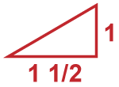  34° (1-1/2:1)

- Any soil that is fissured, seeping water, or was previously disturbed cannot be classified as Type A.
Cave-In Danger Signs

Failure zone:
The failure zone is a distance around the trench which is 50-75% of the trench’s depth. Signs of soil stress, such as tension cracks found in this area, indicate a risk of a cave-in.
Tension cracks:
Tension cracks run parallel to the trench. If found in the failure zone, chances of a cave-in significantly increase.
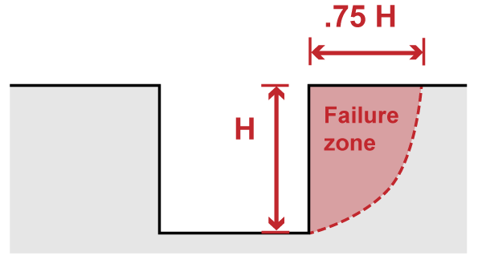 | 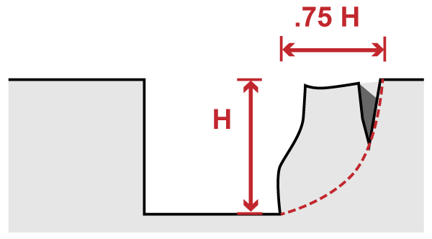

Sliding:  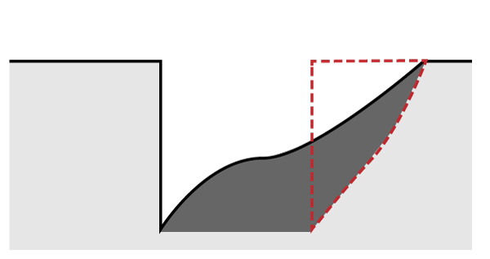Sliding, or sloughing, can occur when the soil is weakened by tension cracks. | Toppling:  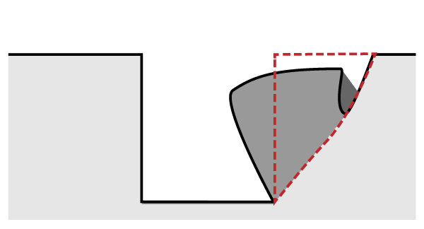Toppling is another potential consequence of tension cracks. The trench’s wall splits along the tension crack line and falls into the trench. | Bulging:  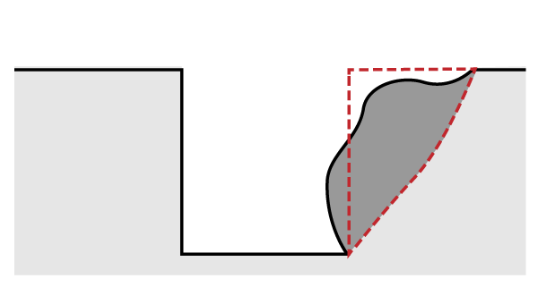Insufficiently supported excavations can lead to uneven stress in the soil. Subsidence, or sinking, in the surface and bulges in the trench’s walls may result.
Never enter an un-shored trench exhibiting any of the conditions listed above!

Cave-In Danger Signs (continued)

Bottom heaving or squeezing:  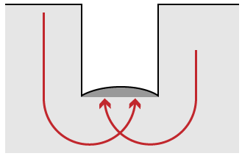Bottom heaving or squeezing occurs when downward pressure from the weight of the adjacent soil causes a bulge in the bottom of the trench.  Soil weight  These conditions can be dangerous if your trench is not properly shored. | Boiling:  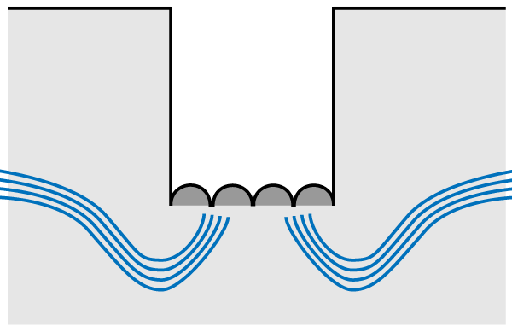Boiling refers to water flowing up into the bottom of the trench, usually due to a high water table. Boiling can create quick conditions in the trench.  Water table

Discussion
Use the remaining time to engage your training group in a discussion about soil mechanics.
- Has anyone observed any of the danger signs discussed above? If so, was the trench adequately shored? How did your crew respond?

This form documents that the training specified above was presented to the listed participants. By signing below, each participant acknowledges receiving this training.

Organization: Date: ________________________

Trainer: Trainer’s Signature: _____

Class Participants:

Name: ____ _______ Signature: ___________
Name: ____ _______ Signature: ___________
Name: ____ _______ Signature: ___________
Name: ____ _______ Signature: ___________
Name: ____ _______ Signature: ___________
Name: ____ _______ Signature: ___________
Name: ____ _______ Signature: ___________
Name: ____ _______ Signature: ___________
Name: ____ _______ Signature: ___________
Name: ____ _______ Signature: ___________
Name: ____ _______ Signature: ___________
Name: ____ _______ Signature: ___________
Name: ____ _______ Signature: ___________
Name: ____ _______ Signature: ___________
Name: ____ _______ Signature: ___________
Name: ____ _______ Signature: ___________

