Earthquake Preparedness
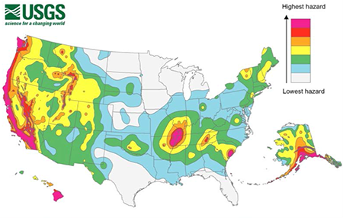
According to the US Geological Survey (USGS), earthquakes can occur in every state, with the West Coast, Alaska, Hawai’i, and regions across the central and southeastern United States at the highest risk.
Fortunately, there are ways to prepare your workplace for when an earthquake does happen.
Workplace preparation:
This USGS map indicates potential earthquake strength, with darker areas indicating stronger quakes.
- Your organization’s Emergency Action Plan should include the following:
- Instructions to follow during and after the event
- Evacuation procedures
- Medical and rescue duties for designated employees
- The plan must consider ground type and building construction as certain ground types and structures are more susceptible to collapse and damage.
- Emergency supply kits should be placed throughout the workplace with such items as flashlights or light sticks, first aid kits and handbooks, blankets, bottled water, dust masks, and fire extinguishers.
- Assure that you complete the necessary training:
- Everyone should be trained in earthquake response procedures, designated safe places, evacuation plans, and the location of emergency supply kits.
- Designated employees can be trained in first aid and fire extinguisher use.
During an earthquake:
- At the first sign of an earthquake, go to a safe place, ideally a sturdy table or desk.
- Drop, cover, and hold on: Drop down, take cover underneath the safe structure, and hold onto something sturdy, e.g., one of the table or desk legs.
- If there are no desks or tables available that you can shelter under, brace against an interior wall away from windows, hanging structures, and tall furniture.
- Make sure to keep your head and neck covered.
- If you are outside when an earthquake happens, stay outside and keep clear from buildings, trees, or overhead objects (e.g., power lines or street lights).
After an earthquake occurs:
- Do not leave the shelter until the shaking has completely stopped.
- When emerging from your shelter:
- Be wary of aftershocks.
- Watch out for fires, which may be caused by broken gas or electrical lines or appliances.
- If you need to leave the building, use the stairs.
Aftershocks:
- Aftershocks follow earthquakes. They are smaller than the earthquake but can still cause damage to weakened structures.
- Aftershocks are difficult to predict and can occur within a couple minutes to several hours, days, months, or even years of the main quake.
Evacuations:
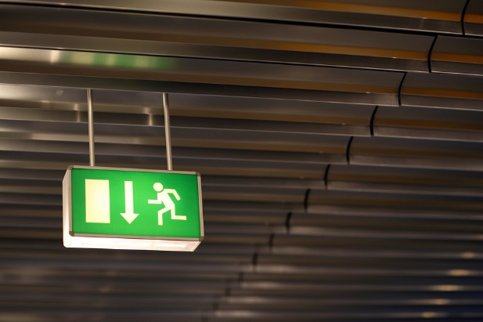
- If instructed to evacuate, do so immediately—do not linger in weakened structures.
- Only evacuate as instructed by emergency response personnel, or if another safe location can be reached before any event is expected to occur.
- Follow any evacuation plans and routes put in place as part of the Emergency Action Plan.

This form documents that the training specified above was presented to the listed participants. By signing below, each participant acknowledges receiving this training.

Organization:

Trainer: Trainer’s Signature:

Class Participants:

Name: Signature: Date:

Name: Signature: Date:

Name: Signature: Date:

Name: Signature: Date:

Name: Signature: Date:

Name: Signature: Date:

Name: Signature: Date:

Name: Signature: Date:

Name: Signature: Date:

Name: Signature: Date:

Name: Signature: Date:

Name: Signature: Date:

Name: Signature: Date:

Name: Signature: Date:

Name: Signature: Date:

Name: Signature: Date:

Name: Signature: Date:

Name: Signature: Date:

