Objective: To familiarize employees with the different types of lens tints for safety glasses and their uses

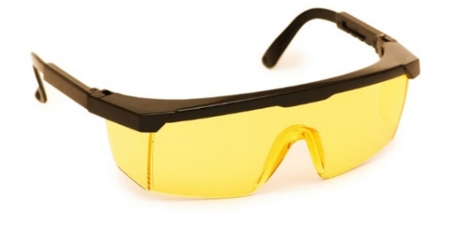
Safety glasses are intended to shield the wearer's eyes from impact hazards such as flying fragment, objects, large chips, and particles.
Safety glasses are available in a variety of different lens tints that are appropriate to different tasks.
Before beginning work, assure that you have the right type of safety glasses for the job.
Common Lens Tints
Lens Tint | Applications
Clear | - Allows the most visible light to pass through  - Gives excellent protection both indoors and outdoors in adequate visibility
Mirrored | - Reduces glare in outdoor settings
Yellow and amber | - Blocks out dark colors (e.g., grays, browns, or blues) and increases the amount of visible light across the lens  - Works well in low-light conditions, such as overcast conditions, early morning, or late evening
Gray and black* | - Provides protection from UV radiation and glare  - Functions optimally when working outdoors in daylight

*Note: Grey and black models intended for use in welding or cutting activities must be specifically rated with the minimum protective shade approved for planned activities.

This form documents that the training specified above was presented to the listed participants. By signing below, each participant acknowledges receiving this training.

Organization: Date:

Trainer: Trainer’s Signature:

Class Participants:

Name: Signature:

Name: Signature:

Name: Signature:

Name: Signature:

Name: Signature:

Name: Signature:

Name: Signature:

Name: Signature:

Name: Signature:

Name: Signature:

Name: Signature:

Name: Signature:

Name: Signature:

Name: Signature:

Name: Signature:

Name: Signature:

