Welding & Hot Work:
Compressed Gas Cylinder Safety
Training Short 2.0

Compressed gas cylinders are a dangerous but necessary aspect of hot work. They may contain toxic, flammable, oxygen-displacing, or explosive materials and can become projectiles if their contents are suddenly and uncontrollably released.
WHAT IS SITUATIONAL AWARENESS?
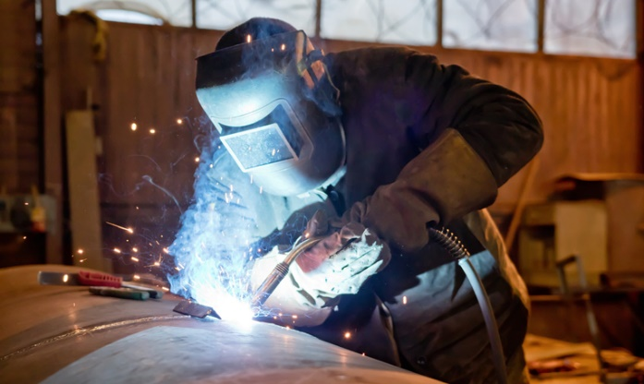
Compressed gas cylinders look different from typical workplace chemicals, but that doesn’t mean they’re any less dangerous. Before bringing compressed gas cylinders into a hot work environment, you should understand their hazardous properties.
- Hazard Communication
  - Before working with compressed gases, ensure you fully understand the risks of using gas cylinders, including hazards specific to the cylinders’ contents.
Personal protective equipment requirements (PPE) vary depending on the type of work you perform. Determine PPE requirements before you begin working as part of your workplace’s hazard assessment.
  - Effectively communicate hazards, safe practices, and personal protective equipment (PPE) requirements through training and safety data sheets (SDSs). SDSs must be accessible to employees who work with hazardous materials.
- Cylinder Identification
  - Use status tags to indicate if the cylinder is full, in use, or empty.
  - Apply labels that are compliant with the Globally Harmonized System of Classification and Labeling of Chemicals (GHS) to cylinders to identify their contents and hazards.
  - Use caution in areas where compressed gas cylinders are stored and always follow posted safety signs.
- Before Use
  - Visually examine the cylinder for:
    - Signs of stress, excessive wear, dents, impact points, rust, or discoloration from chemical reactions or fire/heat exposure.
    - If you find any of these conditions or have other concerns, do not use the cylinder!
  - Check the leads, hoses, cables, and gauges to ensure proper working order.
  - Test connections of valves, hoses, and flashback arrestors.

SPECIAL HAZARDS - ACETYLENE
Compressed gas cylinder hazards vary based on the contents inside. Acetylene is a common flammable gas used in welding operations. It is very unstable and can decompose quickly and violently under high pressures. In a cylinder, it’s stabilized by mixing it with acetone. The cylinder has a filler material that the mixture passes through to slow decomposition. Remember these handling, storage, and use requirements when working with acetylene:
- An air-gas mixture with as little as 2.5% acetylene can be explosive. Use caution when working with flammable gases.

- Never compress acetylene gas beyond 15 psi.

- Acetylene cylinders are fitted with a fuse plug that will melt and shut off the cylinder if the temperature reaches 212°F.
    - If a valve locks, apply lukewarm water to the valve, not the cylinder.
    - Never use a flame or another hot object to thaw a locked valve.
    - Cylinder valves must be closed when the area is unattended.
- Acetylene is a liquid under pressure (LP) gas. As a result, ensure the cylinder is stored upright so the liquid stays on the bottom, away from the valve.
- Many LP gases, including acetylene, are heavier than air. This means the gas will settle close to the ground if there’s a leak.
CYLINDER HANDLING & STORAGE

Take special care when moving, handling, and storing compressed gas cylinders. If a cylinder is hit hard enough, the valve may blow off, causing severe damage and injuries.
Before Moving Cylinders:
- Get authorization.
- Confirm the cylinders’ contents and review the SDS for handling requirements.
- Close valves, bleed the lines, remove regulators, and replace valve safety caps.
- Before you move the cylinder, ensure that your planned route is clear of obstacles.
While Moving Cylinders:
- Use a cart designed for this purpose.
- Stay on designated pathways.
- Never lay cylinders on their sides, and never roll them by hand.
Storage:
Always store cylinders based on SDS instructions as well as local, state, and federal requirements.
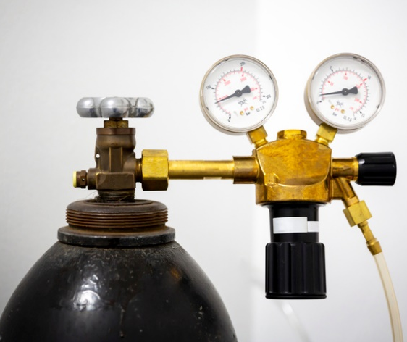
- Keep storage areas cool and dry, well-ventilated, clear of combustible materials, and protected from known hazards.
- Limit storage area access to authorized and trained personnel.
- Keep cylinders upright.
- Remove regulators, bleed lines, and replace valve safety caps.
- Position cylinders where sparks, slag, or flame will not strike them and so that they can’t become part of an electrical circuit.
- Don’t store cylinders with incompatible contents together. For example, keep oxygen cylinders separate from flammable gas cylinders. Take necessary measures to ensure materials are properly segregated and stored.
Inspect cylinder gauges, connections, hoses, and other accessories prior to each use.
Storage and Handling Reminders:
- Do not refill or mix gases in a cylinder.
- Equip all cylinders with a handle or wrench so they can be turned off immediately.
- Provide flashback arrestors/check valves on all oxygen and fuel gas torches.
- To prevent tangling, do not cover more than 4 out of 12 inches of hose with tape when taping parallel hose lengths.
- Use only hose couplings that can’t be unlocked or disconnected using a straight pull.
- Require that the boxes used to store the hose be ventilated.
- String hoses overhead using non-metallic hangers or otherwise position them to keep them clear of walkways, ladders, stairways, or damage.

Welding & Hot Work: Compressed Gas Cylinder Safety -
Training Roster

This form documents that the training specified above was presented to the listed participants. By signing below, each participant acknowledges receiving training on the abovementioned subject. They understand that this training was only a general overview of the subject and that they should contact their supervisor with any questions or concerns.

Organization: ________________________ Date: _________________________________

Trainer: ___________________________ Trainer’s Signature: _____________________
Class Participants:

Name: _____________________________ Signature: ________________________________
Name: _____________________________ Signature: ________________________________
Name: _____________________________ Signature: ________________________________
Name: _____________________________ Signature: ________________________________
Name: _____________________________ Signature: ________________________________
Name: _____________________________ Signature: ________________________________
Name: _____________________________ Signature: ________________________________
Name: _____________________________ Signature: ________________________________
Name: _____________________________ Signature: ________________________________
Name: _____________________________ Signature: ________________________________
Name: _____________________________ Signature: ________________________________
Name: _____________________________ Signature: ________________________________
Name: _____________________________ Signature: ________________________________
Name: _____________________________ Signature: ________________________________
Name: _____________________________ Signature: ________________________________
Name: _____________________________ Signature: ________________________________
Name: _____________________________ Signature: ________________________________

