Objective: To explain the importance of housekeeping in preventing slips, trips, and falls and to give an overview of housekeeping principles, including spill response

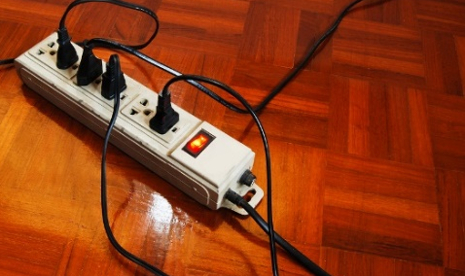
Housekeeping is one of the most important practices for preventing slips, trips, and falls. Obstacles and clutter are a major cause of trips, and floor wetness and contaminants are major causes of slips.
Cleaning and Tidying
- Keep walkways and aisles clear.
- Remove obstacles and anything that is not necessary. Do not allow clutter or trash to accumulate. Keep cords neat and away from areas where people may step.
- Keep floors as clean and dry as possible.
- Minimize dust.
- Follow your organization’s cleaning guidelines.
Storage
- Store equipment and materials properly when not in use.
- Secure items so they will not fall.
- Keep storage areas clean and free of clutter.
Spill Response
- Clean spills promptly (or report them, if applicable).
- If chemical spills are possible, know how to respond and where the appropriate SDSs are.
- Know where wet floor signs are located and use them to warn others of spills. Remove them once the spill is cleaned.
This form documents that the training specified above was presented to the listed participants. By signing below, each participant acknowledges receiving this training.

Organization: Date:

Trainer: Trainer’s Signature:

Class Participants:

Name: Signature:

Name: Signature:

Name: Signature:

Name: Signature:

Name: Signature:

Name: Signature:

Name: Signature:

Name: Signature:

Name: Signature:

Name: Signature:

Name: Signature:

Name: Signature:

Name: Signature:

Name: Signature:

Name: Signature:

Name: Signature:

