Objective: To assure that employees know how potential maintenance issues are identified before serious damage or breakdown occurs

Fleet safety directors have many concerns:

- How familiar are drivers with their equipment?
- How often do they check their vehicles for signs of trouble?
- Do they check their gauges and instrument panels?
- Do they recognize the symptoms leading to mechanical failure and report them?
- Do they listen for odd noises that could possibly lead to a malfunction?

These concerns are valid, especially considering the cost of mechanical failures of fleet equipment.
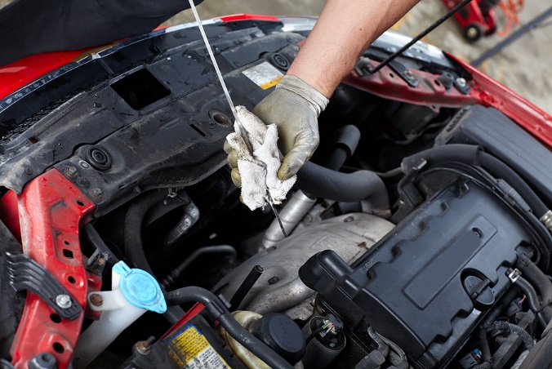
Rules to Assure Proper Maintenance
To assure that your vehicle is properly cared for, conduct an once-over inspection before driving.
- Look over the outside of the vehicle. Go over the vehicle from front to rear, checking for potential problems, such as excessive wear to your tires or non-functional head or tail lights.
- Check around the vehicle’s engine. Look under the hood and be alert for leaks that may indicate trouble.
- Perform an instrument check. Check all instruments carefully to assure that they are functioning properly. Continue to check them while traveling, monitoring the electrical systems, brakes, operating temperatures, etc.

This form documents that the training specified above was presented to the listed participants. By signing below, each participant acknowledges receiving this training.

Organization: Date:

Trainer: Trainer’s Signature:

Class Participants:

Name: Signature:

Name: Signature:

Name: Signature:

Name: Signature:

Name: Signature:

Name: Signature:

Name: Signature:

Name: Signature:

Name: Signature:

Name: Signature:

Name: Signature:

Name: Signature:

Name: Signature:

Name: Signature:

Name: Signature:

Name: Signature:

