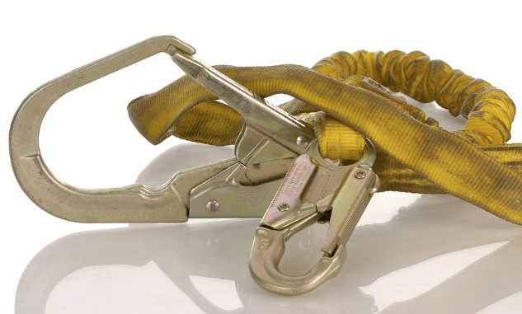
Basic care for fall protection equipment will prolong the life of the equipment and contribute toward the performance of its vital safety function. All parts of a fall arrest system must be inspected regularly—at least every six months by a competent person, or more frequently depending upon wear and conditions.
Inspection procedures must be written. Regular inspections must be documented. Follow the manufacturer inspection instructions, and make them readily available to equipment users. If required by the manufacturer, return the equipment for regular inspections, repairs, or recertification.
It is important to conduct visual inspections prior to each use. Train employees on how to inspect and properly store equipment. If any issues are found, the equipment must be replaced. Remove equipment from service if a stress indicator or warning system, such as red stitching showing through webbing, has been activated. Determine what the manufacturer specifies in this regard and expected service life. Harnesses typically have about a five year service expectancy, even if they never arrest a fall.
If a fall has been arrested by the use of equipment, remove all components of the system from service and follow the manufacturer's instructions for disposal.
Harness inspection:
  - Inspect the harness, beginning at one end. Bend the belt in an inverted "U" in six to eight inch sections.
  - Inspect for frayed edges, broken fibers, pulled stitches, cuts, or chemical damage.
  - Check D-rings and metal wear pads for distortion, cracks, breaks, and rough or sharp edges.
  - Note any of the following: unusual wear; frayed or cut fibers; or distortion of buckles, the attachments of buckles, or D-rings.
  - Rivets must be tight, not able to be removed by fingers, and lay flat against the fabric.
- Buckle tongues must be free of distortion in shape and motion. They must also overlap the buckle frame and move freely back and forth in their socket.
- Rollers must turn freely on the frame.
  - Inspect the friction buckle for distortion, paying special attention to corners and attachment points of the center bar. The outer bar and center bars must be straight.
Lanyard inspection:
- Begin inspecting lanyards at one end and work to the opposite end. Slowly rotate the lanyard so that the entire circumference is checked.
  - While rotating a steel lanyard, watch for cuts, frayed areas, or unusual wear patterns on the wire.
  - Observe each side of the webbed lanyard by bending the webbing over a piece of pipe to reveal any cuts or breaks.
  - Steel, webbed and rope lanyards require the use of a shock absorbing system.
  - The outer portion of the shock-absorbing pack and attached lanyards must be examined for burn holes, tears, loose strands, rips, and deterioration.
Visual inspection of webbing and rope lanyards:
- The rope diameter must be uniform throughout, following a short break-in period. Weakened areas appear as noticeable changes in original diameter.
- Rotate the rope lanyard while inspecting from end to end, looking for any fuzzy, worn, broken, or cut fibers.
- In excessive heat, nylon becomes brittle and has a shriveled brownish appearance. Fibers will break when flexed, and they must not be used in conditions above 180˚F.
- Change in color from chemical exposure usually appears as a brownish smudge. Transverse cracks appear when the belt is bent tightly, causing a loss of elasticity.
- Webbing and rope strands may be fused together by molten metal or flame. Watch for hard, shiny spots, or a hard and brittle feel.
- Paint will penetrate the lanyard material and dry, restricting the movement of fibers. Damage from drying agents and solvents also appear as chemical damage.
Hardware inspection:
- Inspect closely for distortion, cracks, corrosion, or pitted surfaces. Each section must adequately keep the snap closed.
- The thimble (the protective plastic sleeve of a snap) must be firmly seated on the snap.
- The edges of the thimble must not be sharp, distorted or cracked, and they must be free of loose or cut strands.
Cleaning and storage of equipment:
Proper storage and maintenance after use are as important as cleaning the equipment of dirt, corrosives, or contaminants.
- For nylon or polyester: remove all surface dirt with a sponge dampened in plain water.
- To clean, dip a sponge in a mild solution of water and commercial soap or detergent. Work up a thick lather with a vigorous back and forth motion; then wipe with a clean cloth. Hang freely to dry, but away from excessive heat.
- When not in use, fall protection equipment must be stored in a cool, dry, and clean place out of the way and out of direct sunlight. Avoid areas where heat, moisture, oil, chemicals, or other degrading elements may be present.
- Equipment that is damaged or in need of maintenance must be removed from the workplace and not stored in the same area as usable equipment.
- Heavily soiled, wet, or otherwise contaminated equipment must be properly cleaned and dried prior to storage.
  - Prior to using equipment which has been stored for long periods of time, have it inspected thoroughly by a competent person before placing it back in service.

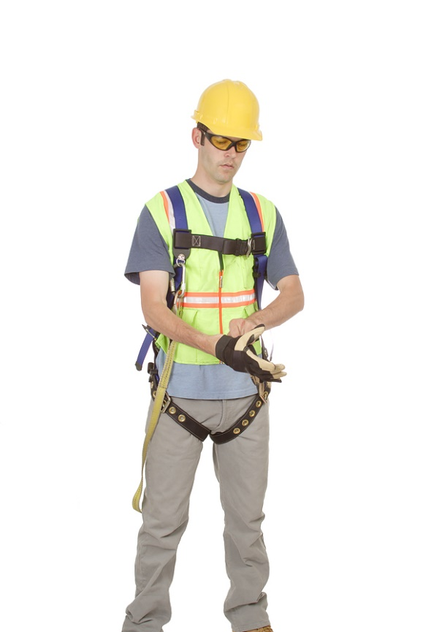

This form documents that the training specified above was presented to the listed participants. By signing below, each participant acknowledges receiving this training.

Organization: Date:

Trainer: Trainer’s Signature:

Class Participants:

Name: Signature:

Name: Signature:

Name: Signature:

Name: Signature:

Name: Signature:

Name: Signature:

Name: Signature:

Name: Signature:

Name: Signature:

Name: Signature:

Name: Signature:

Name: Signature:

Name: Signature:

Name: Signature:

Name: Signature:

Name: Signature:

