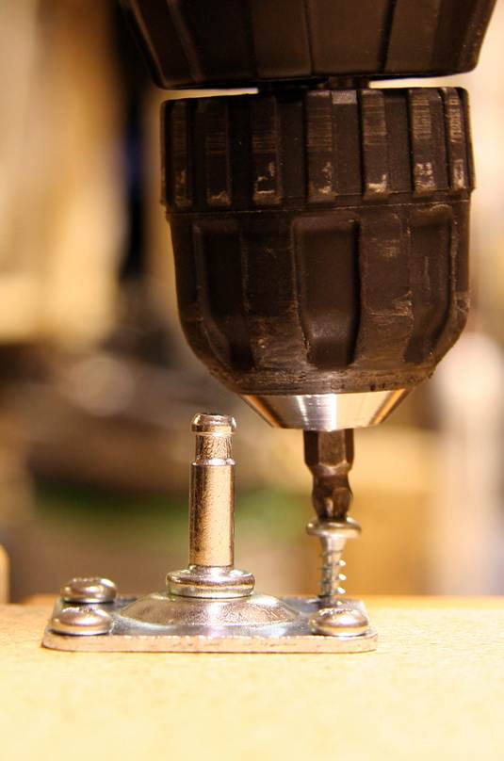
Power tools can be very dangerous when used improperly. Cuts, punctures, electric shock, and burns are common consequences of accidents involving these tools. Always exercise caution when working with or around power tools.
- Keep tools clean. Poor maintenance is responsible for many accidents.
- Ensure that all guards are in place.
- Disconnect the power source before adjusting, oiling or changing accessories – always replace the guards when you are done.
- Ensure that all cords are placed in safe locations, where they do not create a tripping hazard.
- Inspect the insulation on all wires each day. Report all damaged wires.
- Inspect the couplings on pneumatic hoses before each use. Report all damaged couplings immediately.
- Ensure that the tool that you are using is properly grounded.
- Sanders should be moved away from the body when using.
- Only properly trained and certified operators may use powder-actuated tools.
- Tools must always be left unloaded until ready for use. Studs should be driven a safe distance from the edge of material.
- Operators should wear safety goggles or face shields.

This form documents that the training specified above was presented to the listed participants. By signing below, each participant acknowledges receiving this training.

Organization: Date:

Trainer: Trainer’s Signature:

Class Participants:

Name: Signature:

Name: Signature:

Name: Signature:

Name: Signature:

Name: Signature:

Name: Signature:

Name: Signature:

Name: Signature:

Name: Signature:

Name: Signature:

Name: Signature:

Name: Signature:

Name: Signature:

Name: Signature:

Name: Signature:

