Every year there are fires and explosions at work sites around the world because of failure to use and handle acetylene and fuel gases safely. Below, you will find tips on how to keep your workplace from becoming another statistic.
General safety precautions:
These gases are highly flammable. Always use caution and common sense when working with acetylene and other fuel gases.
- Learn the dangers and controls for the gas you are working with and always practice safe handling and transportation methods.
- Avoid smoking around fuel gases and remember it doesn’t take a flame or spark to cause an explosion.
- Many of these gases will ignite between 600˚ F and 800˚ F.
- A spark from any source can cause ignition; defective hoses are the most likely place for gas to escape into a room.
- Be sure to consult your supervisor and the Safety Data Sheet (SDS) about the explosive characteristics of the gas that you are working with and check the manufacturer’s information for the required safety gear.
Working with acetylene:
An air-gas mixture with as little as 2.5% acetylene can be explosive. Other gases have lower explosive limits, so use caution any time a flammable gas is in use.
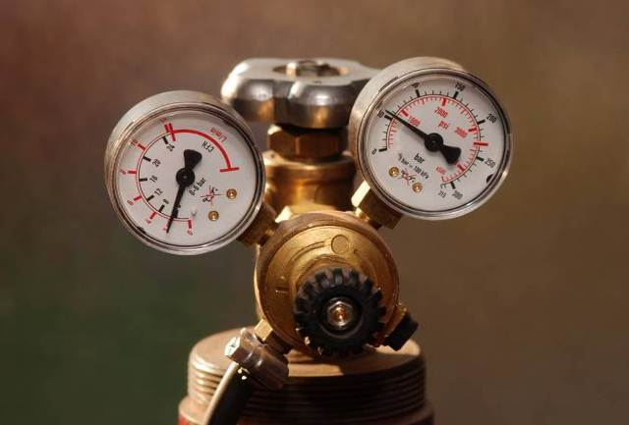
- Never compress acetylene gas beyond 15 psi.
- The cylinders are fitted with a valve that will shut off if the temperature reaches about 200˚ F.
    - If a valve locks, use lukewarm water to cool it off.
    - Apply the water to the valve, not the cylinder.
    - Never use a flame or any other hot object to thaw a locked valve.
    - Cylinder valves must be closed when leaving the job unattended.

Storage and transportation safety:
- Use cylinder carts to move containers and be sure they are secured to prevent tipping.
- Because storage cylinders are often highly pressurized, you must use caution when moving them around. If a cylinder is hit hard enough, the valve may blow off, causing severe damage and injury.
- Use tags to indicate if the container is full, in use, or empty.
- Acetylene is an LP (liquid under pressure) gas. Because of this, it must be stored facing up to assure that the liquid stays on the bottom, away from the valve. This precaution must also be taken with most other fuel gases.
- Many LP gases, including acetylene, are heavier than air. This means that if there is a leak, the gas will rest close to the ground. Other gases, including hydrogen, are lighter than air and will rise when leaked.
- Remember that the pressure within gas cylinders can vary. Acetylene is typically shipped at 220 pounds per square inch (psi), while hydrogen is shipped at 2,000 psi.
- Acetylene can be transported at 220 psi. It becomes very unstable when compressed to anything over 15 psi and can explode regardless of exposure to heat. This is because the gas is shipped with acetone, which allows it to be stored at a much higher pressure than would be used otherwise.

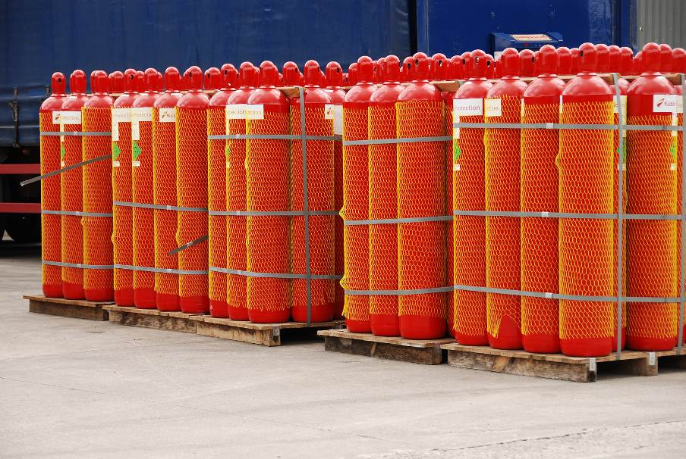

Always know the chemicals you work with. Refer to the SDS or your hazard communication plan.

This form documents that the training specified above was presented to the listed participants. By signing below, each participant acknowledges receiving this training.

Organization: Date:

Trainer: Trainer’s Signature:

Class Participants:

Name: Signature:

Name: Signature:

Name: Signature:

Name: Signature:

Name: Signature:

Name: Signature:

Name: Signature:

Name: Signature:

Name: Signature:

Name: Signature:

Name: Signature:

Name: Signature:

Name: Signature:

Name: Signature:

Name: Signature:

Name: Signature:

