Proactive preventive safety measures:
- Safely covering an opening with a piece of plywood requires more than placing the material over the hole.
- The hole should be covered and secured with a cover large and rigid enough to prevent failure and movement.
- Holes should be marked with danger warnings.
- Every employee on the job should be warned about the hazard.
- Never leave an opening uncovered or unprotected.
- If covering a hole is impractical, guardrails shall be installed with toe boards.
- Floor or platform openings for ladders shall be guarded by standard railings and toe boards on all exposed sides, except at entrances to openings. The entrance must also be protected so that a person cannot walk directly into the opening.

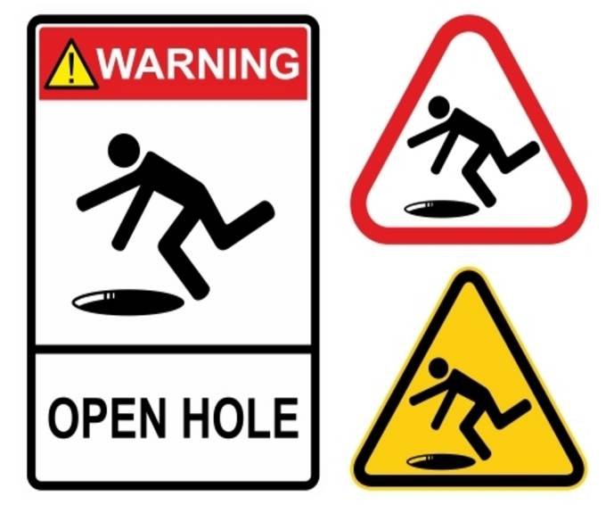

Take all precautionary measures when working around openings and holes in floors and roofs!

This form documents that the training specified above was presented to the listed participants. By signing below, each participant acknowledges receiving this training.

Organization: Date:

Trainer: Trainer’s Signature:

Class Participants:

Name: Signature:

Name: Signature:

Name: Signature:

Name: Signature:

Name: Signature:

Name: Signature:

Name: Signature:

Name: Signature:

Name: Signature:

Name: Signature:

Name: Signature:

Name: Signature:

Name: Signature:

Name: Signature:

Name: Signature:

Name: Signature:

