Workplace & Personal Hygiene
Training Short 2.0

A clean and hygienic workplace helps keep the spread of germs and other infectious diseases at bay. Maintaining a clean workplace can help reduce injuries related to poor housekeeping, such as slips, trips, and falls. By maintaining good personal hygiene, you can also help contribute to an upstanding and hygienic work environment.

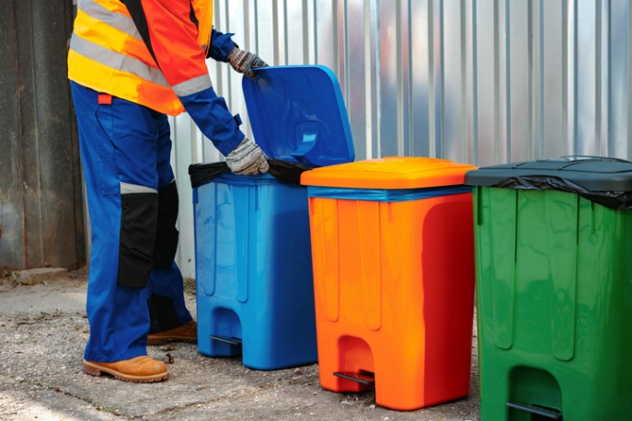
What is Workplace Hygiene?
In its simplest definition, it’s keeping a clean workplace. While keeping things tidy is straightforward, the U.S. Occupational Safety and Health Administration (OSHA) has guidance for general industry workplace sanitation and housekeeping requirements. Their guidance includes:
- Keep floors clean, dry, and free from trip hazards.
- Trash collection containers should be leak-proof and easily cleanable. They should have a lid (unless it can be maintained in a clean condition without one).
Garbage, waste, and other refuse should be removed in a hygienic manner to prevent spills.
- Reduce pest harborages- remove debris, seal cracks, and change trash regularly.
- Potable water must be available for drinking, washing, cooking, and food preparation.
- Suitable restrooms and washing facilities with hot and cold water, soap or similar cleanser, and a cloth or other agent to dry hands must be available at on-site locations. Mobile workers must have the ability to access restrooms that meet these same standards.
- Food preparation, storage, and handling areas should be kept clean and free from hazardous contaminants.
Implementing Workplace Hygiene Practices
Depending on the hazards at your workplace, you may need different or more stringent workplace hygiene practices. OSHA’s General Duty Clause states, “Each employer shall furnish...a place of employment which are free from recognized hazards that are causing or are likely to cause death or serious physical harm...” Solid facility maintenance practices can help maintain a hygienic workplace.

- Check air and water quality regularly. This should be done by qualified personnel.
- Perform preventative maintenance inspections.
- Add sanitation stations in high touchpoint/traffic areas. Having stations set up in places where customers, employees, and other visitors congregate can help reduce the spread of germs.
- Maintain adequate supplies of sanitary and cleaning products. Be prepared for emergencies.
Remember: Report safety concerns to your supervisor!

Personal Hygiene in the Workplace
Having good personal hygiene at work plays a part in keeping the workplace clean, promoting a positive standard to customers, and maintaining quality control in your product. You may have a hygiene policy outlined in your employee handbook, code of conduct, company dress code, or similar standard document.

Personal hygiene issues can be delicate to discuss. If you have a concern, it is best to have it addressed by a trained supervisor or human resources person. Remember that everyone has different health and personal conditions, cultural practices, and other factors that may be at play. Those investigating the issue should:
Address personal hygiene matters discreetly.

- Handle the conversation with sensitivity and privacy. Everyone should be treated with respect!
- Explain the issue or concern. They may be unaware of the problem.
- If the employee voluntarily discloses that the odor is part of an underlying medical condition, that means the employee is protected by the Americans with Disabilities Act (ADA) and should be allowed reasonable accommodations. (Note: You cannot be the one to ask the employee if they have an underlying medical condition or any other disability; that would be an ADA violation.)
- Work with the employee to accommodate and address the issue.
Personal Hygiene & Safety
Personal Hygiene is an important part of many safety-related tasks.

Preventing the Spread of Diseases & Germs
The U.S. Centers for Disease Control and Prevention (CDC) recommends taking the following steps to reduce your risk of contracting viruses, including COVID-19:
- Avoid close contact with people who are sick (staying 6 feet away or more is recommended). If you are sick, please stay home or wear a face mask to prevent others from getting sick.
- Wash your hands often with soap and water for at least 20 seconds, especially after blowing your nose, coughing, sneezing, or having been in a public place.
- If soap and water are not available, use a hand sanitizer that contains at least 60% alcohol.
- To the extent possible, avoid touching things — elevator buttons, door handles, handrails, etc. — in public places. Use a tissue or your sleeve to cover your hand or finger if you must touch something.
- Avoid touching your face, nose, eyes, etc.
- Clean and disinfect your home and workplace to remove germs. Don’t forget to wipe down frequently touched surfaces, including tables, doorknobs, light switches, handles, toilets, faucets, sinks, and cell phones.
- Avoid crowds, especially in poorly ventilated spaces.

Workplace & Personal Hygiene - Training Roster

This form documents that the training specified above was presented to the listed participants. By signing below, each participant acknowledges receiving training on the abovementioned subject. They understand that this training was only a general overview of the subject and that they should contact their supervisor with any questions or concerns.

Organization: ________________________ Date: _________________________________

Trainer: ___________________________ Trainer’s Signature: _____________________
Class Participants:

Name: _____________________________ Signature: ________________________________
Name: _____________________________ Signature: ________________________________
Name: _____________________________ Signature: ________________________________
Name: _____________________________ Signature: ________________________________
Name: _____________________________ Signature: ________________________________
Name: _____________________________ Signature: ________________________________
Name: _____________________________ Signature: ________________________________
Name: _____________________________ Signature: ________________________________
Name: _____________________________ Signature: ________________________________
Name: _____________________________ Signature: ________________________________
Name: _____________________________ Signature: ________________________________
Name: _____________________________ Signature: ________________________________
Name: _____________________________ Signature: ________________________________
Name: _____________________________ Signature: ________________________________
Name: _____________________________ Signature: ________________________________
Name: _____________________________ Signature: ________________________________
Name: _____________________________ Signature: ________________________________
Name: _____________________________ Signature: ________________________________

