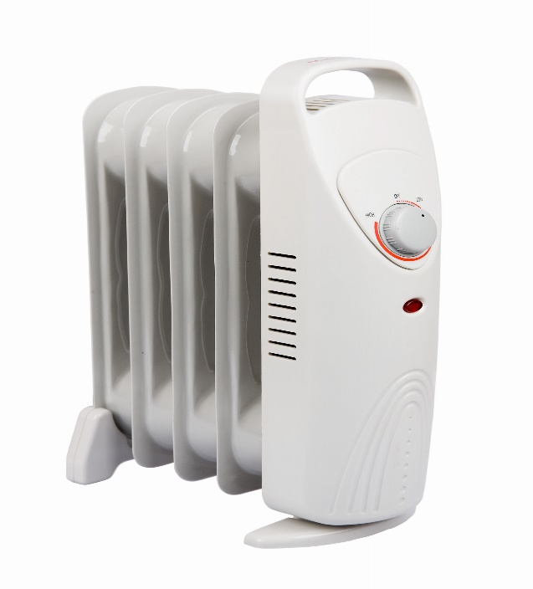
Use of space heaters:
According to the Consumer Product Safety Commission, millions of consumers rely on portable and in-wall gas or electric space heaters to warm their homes and offices. Many of these users fail to follow important safety instructions, not knowing perhaps that death and serious injury, including burns and carbon monoxide poisoning, can occur.
- Every year, people receive emergency room treatment for injuries associated with the use of gas, kerosene, oil, and electric space heaters.
- More than two-thirds of those injured are children under the age of five.
Carbon monoxide poisoning:
Fuel-oil space heaters emit significant amounts of carbon monoxide gas—which is odorless, tasteless, colorless, and can kill a person in a short period of time.
- Non-vented heaters which burn natural gas, liquefied petroleum, and other fuels pose the threat of carbon monoxide poisoning because they need to be used where there is access to fresh air to operate safely. Such non-vented heaters have been outlawed in many areas.
- Symptoms of carbon monoxide poisoning can be as mild as drowsiness, headaches, and nausea and are frequently misdiagnosed.
  - Exposure to carbon monoxide is of special concern to those with heart problems, the elderly, pregnant women, and the very young.
  - Significant overexposure results in severe injuries including permanent brain damage and death.
Burns and structural fires:
Consider the problems common to all space heaters:
- Children and adults often contact exposed flames or hot heater surfaces and suffer severe burns.
- Clothing, fabrics, and other materials that come in contact with heaters cause serious burn injuries and fires.
Installation:
- Use qualified service personnel to install or repair in-wall heaters.
Location of space heaters:
- Locate heaters away from traffic and play areas, as well as areas occupied by children. Keep them clear of furniture, draperies, and other combustibles.
- Alert children and adults about where heaters are located and remind them of the hazards of their high surface temperatures.
- Supervise young children when they are near space heaters.
Recommendations for use:
- Only use heaters that are thermostatically controlled.
- Warn children not to insert fingers or other objects into any heater openings where they can be burned or receive an electric shock.
- Do not use extension cords with electric heaters.
- Use only portable heaters that are equipped with an automatic shut off device that shuts off the heater if it is tipped over.
- If possible, use heaters that are equipped with automated high temperature switches that prevent them from overheating.
- Do not use a portable electric heater in a bathroom or around wet or grounded surfaces.
- Never place a heater near a tub or sink where it could get splashed or fall into the water.
- The filling of all fueled heaters needs to be well controlled in a safe and well- ventilated area, away from ignition sources.
- Never fill a heater when it is hot or in use and follow all manufacturers’ instructions.
- Never substitute a heater’s proper fuel with a different type of fuel and never convert a heater to a different type of fuel.
- All heating equipment should be inspected before use and in accordance with the manufacturer’s instructions.

This form documents that the training specified above was presented to the listed participants. By signing below, each participant acknowledges receiving this training.

Organization: Date:

Trainer: Trainer’s Signature:

Class Participants:

Name: Signature:

Name: Signature:

Name: Signature:

Name: Signature:

Name: Signature:

Name: Signature:

Name: Signature:

Name: Signature:

Name: Signature:

Name: Signature:

Name: Signature:

Name: Signature:

Name: Signature:

Name: Signature:

Name: Signature:

Name: Signature:

