Working with metals can create potentially harmful dust, vapors and fumes. Although inhalation is the most common way for toxic metals to enter the body, it is also possible to ingest metallic substances while smoking, eating or drinking if the proper precautions are not taken.

Following a few simple rules can protect you from metal exposure:
- Know what is in the metals you are working with.
- Know the hazards associated with the materials you are using.
- When dust or fumes are produced, use the appropriate respirator properly.
- Always make sure you have plenty of ventilation.
- Pay attention to personal hygiene and housekeeping.
- Before eating, drinking and smoking, wash your hands and
always keep your work area separate from your lunch area.

Here are a few common metals and the potential hazards that exist with each:
- Zinc, copper, brass and magnesium: Fumes, powders and compounds of these metals are sometimes encountered in welding, brazing, cutting and spray metalizing work.
- Inhalation of these metals can cause metal fume fever, a flu-like condition with coughing, shortness of breath, fatigue, fever, chills, profuse sweating and chest pains.
- Cadmium: Cadmium and its compounds can be toxic. Welding cadmium coated metals is the most common cause of exposure. Adequate ventilation and an approved respirator will help protect you.
  - Metal fume fever can occur when small doses are inhaled.
  - In larger doses, cadmium inhalation can be fatal.
  - Small repetitive doses can cause kidney damage or lead to emphysema.

- Nickel: Exposure to metal dust or fumes containing nickel and nickel compounds can:
- Inflame and irritate the skin causing an itching rash.
- Inhalation of nickel compounds has been linked to cancer of the lungs and nasal sinuses.
- Lead: Soldering pipes, casting lead seals and repairing piping are common procedures associated with lead.
- Early signs of lead poisoning tend to be ignored and include fatigue, irritability, headache, cramps, stomach pain and loss of appetite.
- Continual buildup can damage the nervous system, brain, kidneys and reproductive system.
- It is also found in gasoline, canned food and most city water supplies.

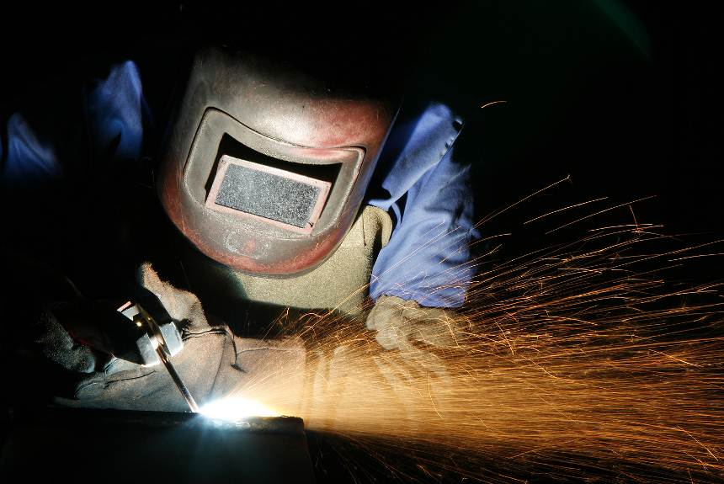

Know the metals you are working with, and
take the proper precautions to keep yourself safe.

This form documents that the training specified above was presented to the listed participants. By signing below, each participant acknowledges receiving this training.

Organization: Date:

Trainer: Trainer’s Signature:

Class Participants:

Name: Signature:

Name: Signature:

Name: Signature:

Name: Signature:

Name: Signature:

Name: Signature:

Name: Signature:

Name: Signature:

Name: Signature:

Name: Signature:

Name: Signature:

Name: Signature:

Name: Signature:

Name: Signature:

Name: Signature:

Name: Signature:

