Objective: To inform employees about proper practices for computer monitor setup that will reduce the risk of eye strain

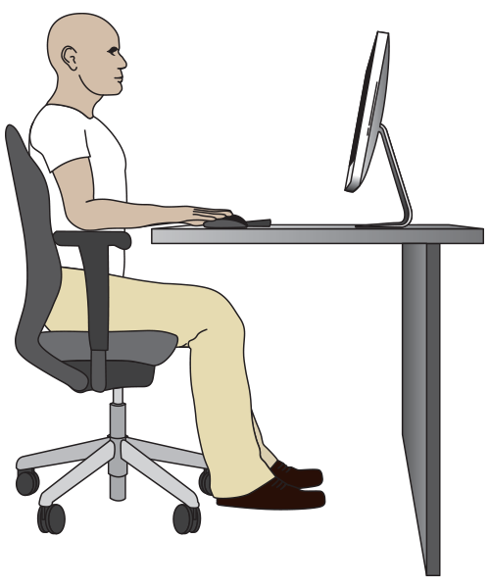
Employees that spend most of their time at work in front of computer monitors may be at risk of eye strain.
Eye Strain Causes
- Position: Monitors placed too close, too far away, or at an angle to your field of vision, making it difficult to focus
- Brightness: Screens that are too bright or too dim and high- or low-contrast images or text bodies, which can lead to eye fatigue and dryness
Solutions
- Follow ergonomic best practices when positioning your computer screen:
- Height: Your eye level falls within 2” – 3” of the top of the screen.
- Distance: The screen should be 16” – 28” away from your eyes.
- Position: Place your primary monitor directly in front of you.
- Lighting: Place your monitor perpendicular to the strongest source of natural light, and so that artificial light sources are overhead or to the side.
- Adjust your monitor’s brightness and contrast settings to a comfortable level.
- Take breaks that allow your eyes to focus on other objects, such as a clock on a wall across the room.
- Break up long periods of computer work with other duties such as filing, phone calls, or meetings.

This form documents that the training specified above was presented to the listed participants. By signing below, each participant acknowledges receiving this training.

Organization: Date:

Trainer: Trainer’s Signature:

Class Participants:

Name: Signature:

Name: Signature:

Name: Signature:

Name: Signature:

Name: Signature:

Name: Signature:

Name: Signature:

Name: Signature:

Name: Signature:

Name: Signature:

Name: Signature:

Name: Signature:

Name: Signature:

Name: Signature:

Name: Signature:

Name: Signature:

