Objective: To understand the risks of various fire scenarios and to be able to determine if it is appropriate to try to fight the fire.

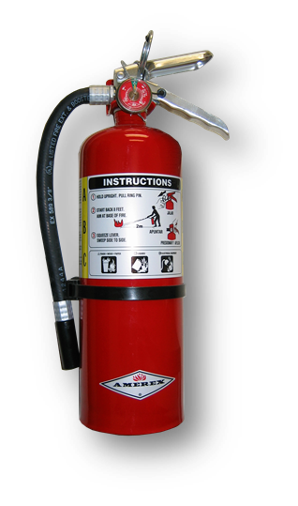
Prior to fighting any type of fire with a fire extinguisher, a risk assessment must be performed to evaluate such conditions as the fire size, fuel type, evacuation routes, and other hazards in the area.
Risk assessment questions:
The following questions will help you decide if you should stay and fight a fire or if you should evacuate the building:
Do you know the fuel source of the fire?
- Should you stay and fight the fire?
  - Yes: If you are aware of the fire’s fuel source and the appropriate class of extinguisher is readily available.
  - No: If the fuel source or type is unknown, or involves flammable solvents or hazardous materials, or if there are no available extinguishers able to fight the type of fire occurring.
Is the fire too big?
- Should you stay and fight the fire?
  - Yes: If the fire is limited to the original material ignited, is contained (e.g., in a waste basket), and is not higher than your head.
  - No: If the fire involves flammable solvents or hazardous materials, has spread over more than 60 square feet, is partially hidden behind a wall or ceiling, cannot be reached from a standing position, or poses other serious hazards.
Risk assessment questions (continued):
Is the air safe to breathe?
- Should you stay and fight the fire?
  - Yes: If the fire is producing only a small amount of smoke that will not likely deplete the oxygen in the room. Smoke may be accumulating at the ceiling, but visibility is good and no respiratory protection is required.
  - No: If the smoke is quickly filling the room, decreasing visibility, or creating a respiratory hazard in which the fire cannot be fought without respiratory protection.
Is the environment too hot or smoky?
- Should you stay and fight the fire?
  - Yes: If heat is being generated but the room temperature is not increasing and no special personal protective equipment is required.
  - No: If the heat radiated is easily felt on exposed skin, making it difficult to approach within the effective range of the extinguisher.
Is there a safe evacuation path?
- Should you stay and fight the fire?
  - Yes: If there is a clear evacuation route behind you as you fight the fire.
  - No: If the fire is not contained and fire, heat, smoke, or debris may quickly block the evacuation route.

This form documents that the training specified above was presented to the listed participants. By signing below, each participant acknowledges receiving this training.

Organization: Date:

Trainer: Trainer’s Signature:

Class Participants:

Name: Signature:

Name: Signature:

Name: Signature:

Name: Signature:

Name: Signature:

Name: Signature:

Name: Signature:

Name: Signature:

Name: Signature:

Name: Signature:

Name: Signature:

Name: Signature:

Name: Signature:

Name: Signature:

Name: Signature:

Name: Signature:

