Molds are everywhere and have existed for millions of years.

When mold spores drift through the air and land on moist surfaces such as damp wood, paper, carpet, food, ceiling tiles, insulation, drywall, wallpaper, or fabric they can grow and spread. We can’t eliminate mold, but to avoid potential harm to buildings and occupants, we can and should take steps to keep mold from growing in our working and living areas.

A threat to health?

For most of us there is little toxic effect from the mold in the air we breathe. Infants; the elderly; and people with allergies, asthma, or weakened immune or respiratory systems may be more sensitive to airborne mold. Eating moldy food is the most common route-of-entry for mold toxins. Some occupations, such as farming and greenhouse work, where moisture and mold are common, present a higher risk of inhalation exposure. Symptoms of mold sensitivity include nasal stuffiness, eye irritation, shortness of breath, or, in rare cases, lung infections (there are other contaminants that cause health problems similar to mold exposure, so it is important that a proper medical evaluation be done to identify the true source of any health problems).

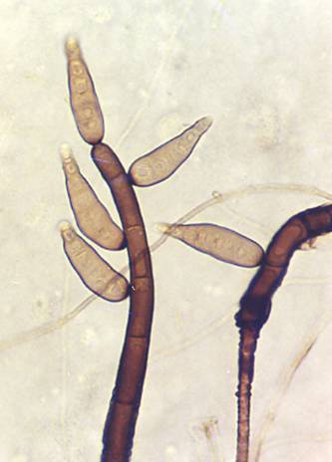
The key to mold control is moisture control.

If surfaces and materials are dry, mold cannot grow. If mold is present, proper procedures must be followed to remove the mold, clean or replace the contaminated surfaces, and eliminate the source of the excessive moisture. Corrective actions include:

- Clean up spills immediately and inspect sinks and cabinets for standing water.
- Repair leaky plumbing, windows, etc.
- Carefully monitor carpets that lay on concrete floors.
- Use kitchen and bathroom exhaust fans (and open a window) when steam and moisture are in the air.
- Use a dehumidifier to maintain a relative humidity of 30% to 50%.
- Keep areas of window condensation clean and dry.
- Do not put carpet in bathrooms.
- Clean drip-pans under air-conditioners, refrigerators, and dehumidifiers - establish preventative maintenance programs for these pieces of equipment.

- Repair cracks in basement walls and slope landscaping away from the building.
- When repainting in moist rooms, use a mold inhibiting agent in the paint.
- Put a plastic barrier on the ground in the crawlspace under the building.
- Maintain roofing, roof gutters, and drainage systems properly.

Cleaning Mold:

Those who investigate, clean, and remove mold contamination should avoid exposing themselves and others to mold-laden dust and materials. Sampling for exact mold identification is usually not necessary - unless serious health or legal issues are a concern.

The magnitude of the mold contamination determines the amount of precautions necessary to do a proper clean up. Mold remediation training must be taken to understand the required procedures and the required Personal Protective Equipment, such as impermeable gloves, splash-proof safety goggles, and appropriate respirators. Room ventilation or area isolation may also be needed depending on the situation. If “mold-killing agents” are used, all use-instructions must be carefully followed. For large or persistent areas of mold growth, seek professional help.

Mold contamination must be cleaned AND removed as even dead mold continues to pose hazards. Contaminated non-porous surfaces must be thoroughly cleaned and dried. Often, porous surfaces must be discarded and replaced. All contaminated waste materials must be securely double-bagged, but can usually be discarded as ordinary construction waste - check with your local waste-handling service.

After cleaning and drying, revisit the area occasionally to ensure that the problem does not return.

This form documents that the training specified above was presented to the listed participants. By signing below, each participant acknowledges receiving this training.

Organization: Date:

Trainer: Trainer’s Signature:

Class Participants:

Name: Signature:

Name: Signature:

Name: Signature:

Name: Signature:

Name: Signature:

Name: Signature:

Name: Signature:

Name: Signature:

Name: Signature:

Name: Signature:

Name: Signature:

Name: Signature:

Name: Signature:

Name: Signature:

Name: Signature:

Name: Signature:

