Hand trucks are effective for reducing strain while moving heavy materials. However, injury can still occur. Use the following tips to prevent strains, trips and falls when using a hand truck.

Lifting practices:
- Load and unload the hand truck carefully, following proper lifting technique.
- Always keep your back straight while lifting.
- Get help if the load is too bulky for proper lifting techniques to work or if the load cannot be handled safely for any reason.

Before moving a load:
- Prepare the path.
  - Inspect and clear your path for ease of movement.
  - Use ramps if the path has stairs or curbs.
  - Measure openings to be sure that there is enough space.
  - Clear the set point.
- Ensure that you have a good view of your path. The load should not be so tall that it obscures your vision.
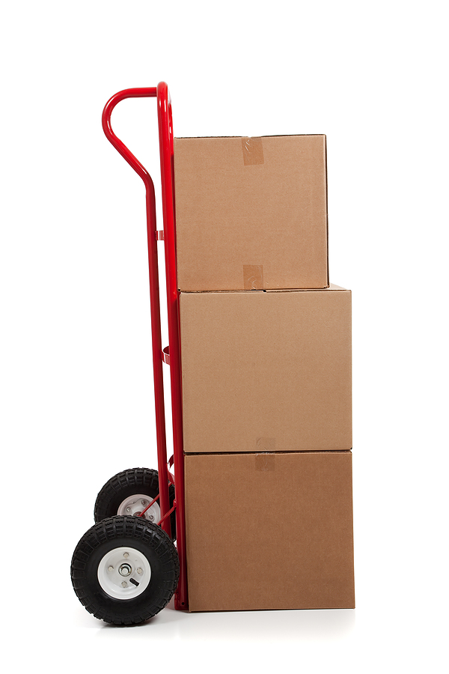
- Put the heaviest part of the load on the bottom of the hand truck.
- Secure the load as needed, and ensure that the straps are tight.
- Inspect equipment before use.
- Check the tire pressure. Balloon-type tires are more prone to losing pressure, adding strain on the person pushing the hand truck.

Using the hand truck:
- Grip the hand truck firmly. Push with a straight back, leaning into your walk.
- Walk forwards, unless you are trapped in a tight space.
- Push or pull loads with both hands.
- Tilting the truck back enables you to push the load uphill more easily, but be aware that this action increases the overall weight that you are carrying.

General safety:
- Ensure that you are trained and authorized for work.
- Wear supportive, closed toe, and non-slip shoes.

This form documents that the training specified above was presented to the listed participants. By signing below, each participant acknowledges receiving this training.

Organization: Date:

Trainer: Trainer’s Signature:

Class Participants:

Name: Signature:

Name: Signature:

Name: Signature:

Name: Signature:

Name: Signature:

Name: Signature:

Name: Signature:

Name: Signature:

Name: Signature:

Name: Signature:

Name: Signature:

Name: Signature:

Name: Signature:

Name: Signature:

Name: Signature:

Name: Signature:

