Objective: To assure that all personnel can recognize common types of aerial lifts and elevated platforms, and are familiar with their minimum safety requirements.

Lift Type | Characteristics | Requirements
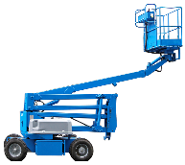  Articulating Boom Lift | - Two or more hinged boom sections.  - Platform moves in multiple directions. | - Only use on a level surface.  - Use fall protection.
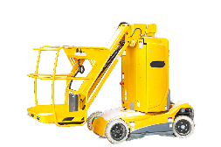  Elevated Work Platform | - Elevates on a vertical axis.  - Stationary after setup. | Fall protection is recommended as a best practice.
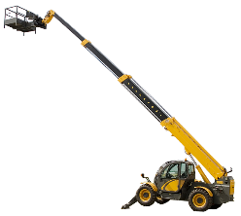  Extensible Boom Platform | Uses a telescopic boom and personnel platform attachments. | - Only use on a level surface.  - Use fall protection.
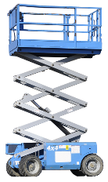  Scissor Lift | - Typically able to lift more than one person at a time.  - Can be moved while platform is raised. | Fall protection is recommended as a best practice.
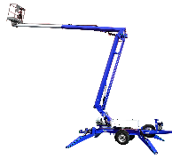  Trailer-Mounted Aerial Lift | - Includes outriggers.  - May be articulated, telescoping, or both.  - Towed to worksites. | - Un-hitch and engage outriggers prior to use.  - Use fall protection.
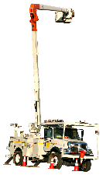  Vehicle-Mounted Aerial Lift | - Typically uses a bucket to lift a single person.  - May be articulated, telescoping, or both. | - Engage brakes, chock wheels, and extend outriggers during use.  - Use fall protection.

This form documents that the training specified above was presented to the listed participants. By signing below, each participant acknowledges receiving this training.

Organization: Date:

Trainer: Trainer’s Signature:

Class Participants:

Name: Signature:

Name: Signature:

Name: Signature:

Name: Signature:

Name: Signature:

Name: Signature:

Name: Signature:

Name: Signature:

Name: Signature:

Name: Signature:

Name: Signature:

Name: Signature:

Name: Signature:

Name: Signature:

Name: Signature:

Name: Signature:

