Objective: To help you maintain emergency eyewashes and showers and to know how to use them in an emergency.

Many chemicals, including acids and bases, are corrosive and can easily damage employees’ skin and eyes. The severity of the damage depends on how strong the chemical is, the length of contact, and what happens next. The first 10-15 seconds after exposure to a hazardous substance are critical. Delaying treatment may cause serious injury. Eyewash stations and safety showers provide on-the-spot decontamination. Their use is followed by more in-depth medical attention.

Chemical Precautions
Employees in many industries have the potential to be exposed to hazardous chemicals. You can take numerous precautions to protect yourself from dangerous chemical exposures:
- Check the chemical’s Safety Data Sheet (SDS) to learn more about its hazards and exposure risks, required personal protective equipment (PPE), and first aid and emergency response procedures.
  - Pay special attention to PPE requirements for corrosive chemicals, as they can cause serious and immediate damage to the eyes and skin.
- Perform a job hazard analysis to find the controls needed to work safely with the chemical.
The Safety Data Sheet (SDS) provides information on a chemical’s hazards and requirements for safe use. SDSs are required to be made readily available by your employer.
- Follow proper hazard identification procedures, such as displaying hazard warning signs near chemical storage areas and following container labeling requirements.
- Follow all storage and separation requirements, such as segregating acids and bases and closing all containers when not used.
Eyewash Station and Safety Shower Selection
Eyewash station and safety shower requirements are outlined by The U.S. Occupational Safety and Health Administration’s (OSHA) Medical and First Aid Standard 29 CFR 1910.151(c). It states the following for eyewash stations and safety showers:
Where the eyes or body of any person may be exposed to injurious corrosive materials, suitable facilities for quick drenching or flushing of the eyes and body shall be provided within the work area for immediate emergency use.

OSHA also references The American National Standards Institute (ANSI) and the International Safety Equipment Association (ISEA) ANSI/ISEA Z358.1 American National Standard for Emergency Eyewash and Shower Equipment recommendations for eyewash and safety shower station location, operation, and testing.

To determine what type of equipment you may need, refer to a chemical’s SDS, your job hazard analysis, and look around your facility. Consider the following:

- Are you using injurious corrosive materials?
- Is an eyewash or safety shower listed as required safety equipment for first aid measures in the chemical’s SDS?
- Do you have a risk of chemicals being spilled, splashed, or otherwise contacting large areas of an employee’s face or body?
- Does your facility have adequate utilities for water-supplied stations, or will you need to add utilities or use self-contained units where regulations permit?
Remember: Outdoor and mobile workers who use injurious corrosive chemicals must also have appropriate eyewash and safety shower stations in case of an emergency.
Safety Equipment Best Practices

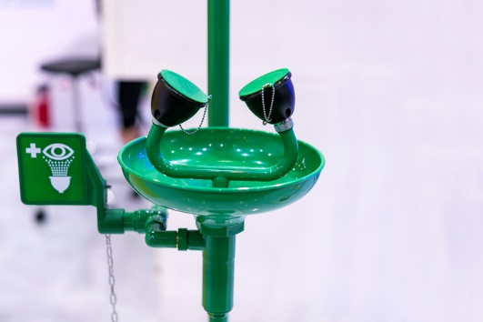
ANSI Z385.1 standard guidance includes the following recommendations:

- Stations should be in accessible locations, ideally within 10 seconds of a hazardous location, like corrosive or toxic chemical storage areas. They must not be through doorways that require opening a door to get to the eyewash station.
- Stations must have an on/off pedal or valve that activates within 1 second by a single motion, and the station should remain on for continuous flow.
Dust covers on spray heads help prevent the buildup of dust or contaminants that could otherwise lower water flow.

- Stations must be located in areas without obstacles and identified with signage.
- Flush the affected area for at least 15 minutes, or as specified on the SDS, using a large supply of clean water under low pressure.
  - For safety shower use, if skin exposure occurs, activate the shower and have employees remove PPE and clothing.
- Seek medical attention as soon as possible.
- Employees must be trained on station functionality and use.
- Assure proper maintenance with weekly recorded testing of eyewash stations.
  - Detailed inspections must include fluid flow tests, unit functionality, and a physical examination of the unit. In addition, lines are to be cleaned to prevent sedimentation buildup.

This form documents that the training specified above was presented to the listed participants. By signing below, each participant acknowledges receiving training on the abovementioned subject. They understand that this training was only a general overview of the subject and that they should contact their supervisor with any questions or concerns.

Organization: ________________________ Date: _________________________________

Trainer: ___________________________ Trainer’s Signature: _____________________
Class Participants:

Name: _____________________________ Signature: ________________________________
Name: _____________________________ Signature: ________________________________
Name: _____________________________ Signature: ________________________________
Name: _____________________________ Signature: ________________________________
Name: _____________________________ Signature: ________________________________
Name: _____________________________ Signature: ________________________________
Name: _____________________________ Signature: ________________________________
Name: _____________________________ Signature: ________________________________
Name: _____________________________ Signature: ________________________________
Name: _____________________________ Signature: ________________________________
Name: _____________________________ Signature: ________________________________
Name: _____________________________ Signature: ________________________________
Name: _____________________________ Signature: ________________________________
Name: _____________________________ Signature: ________________________________
Name: _____________________________ Signature: ________________________________
Name: _____________________________ Signature: ________________________________
Name: _____________________________ Signature: ________________________________
Name: _____________________________ Signature: ________________________________
Name: _____________________________ Signature: ________________________________
Name: _____________________________ Signature: ________________________________
Name: _____________________________ Signature: ________________________________

