Objective: To communicate basic requirements for electrical disconnects

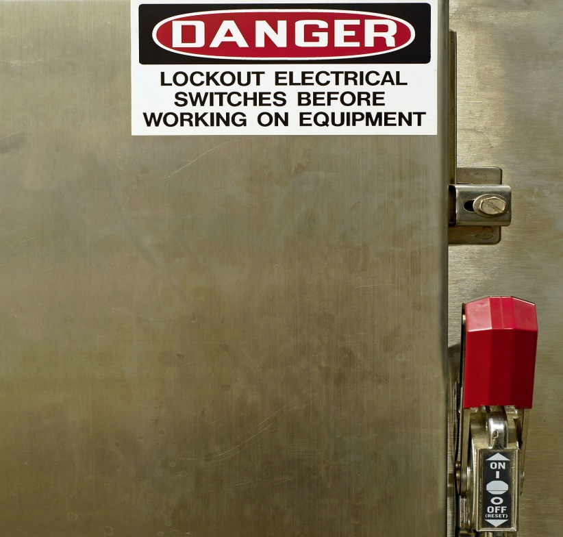
Examples of Electrical Disconnects
- Circuit breakers
- Single and three phase knife switch disconnects
Requirements
- Know the location of circuit breakers and disconnects so they may be accessed and shut off in an emergency.
- Circuit breakers and disconnects need to be marked in accordance with the equipment they service.
- These markings allow the proper location of energy isolation devices for lockout/tagout activities in accordance with your organization’s energy control procedures.
- Circuit breaker identification listings need to be present near or on the inside door of panel boxes that house circuit breakers. Assure that they correspond to circuit breaker disconnects inside of the panel boards.
- Keep areas around electrical disconnects clear to allow access.
- Do not use them as storage areas.
- There should be at least three feet (more for higher voltages) of clearance in front of, and to the side of, electrical equipment.
- Assure electrical disconnects are correctly marked and correspond to the equipment’s energy control procedures for lockout activities.
- Missing circuit breakers in panel boxes must have “blanks” installed to prevent access to energized parts.

This form documents that the training specified above was presented to the listed participants. By signing below, each participant acknowledges receiving this training.

Organization: Date:

Trainer: Trainer’s Signature:

Class Participants:

Name: Signature:

Name: Signature:

Name: Signature:

Name: Signature:

Name: Signature:

Name: Signature:

Name: Signature:

Name: Signature:

Name: Signature:

Name: Signature:

Name: Signature:

Name: Signature:

Name: Signature:

Name: Signature:

Name: Signature:

Name: Signature:

