Objective: To reinforce awareness of the health risks and prevention methods associated with West Nile Virus

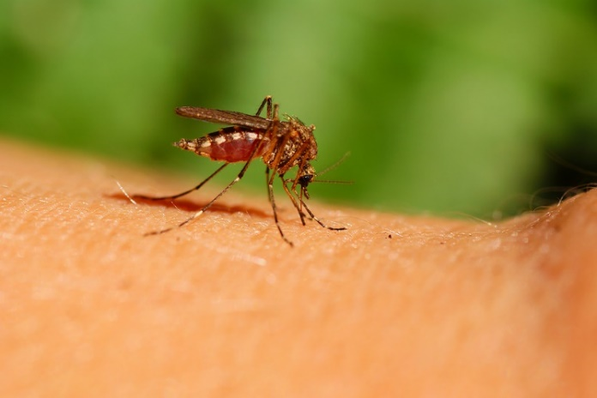
The West Nile Virus (WNV) is thought to be spread when a mosquito bites an infected bird and then a person.
While commonly found in Africa, West Asia, and the Middle East, WNV is believed to be a seasonal epidemic in North America from summer to fall.
When dealing with WNV, prevention of mosquito bites is the best tactic.
Illness and Symptoms
- The chance of becoming ill from a single mosquito bite remains low.
      - 80% of people infected with WNV will not show any symptoms at all. Of the 20% who do exhibit symptoms, the chance of severe symptoms only occurs in less than 1%.
      - Symptoms include:
- Skin rash
- Swollen lymph glands
- Fever
- Headache
- Muscle ache
- Exhaustion
- In severe cases, encephalitis, which can be fatal
- Symptoms can last for weeks.
- The risk of severe illness and death is highest for people over 50 years old, although people of all ages can become ill.
- If you think you might have WNV, consult a healthcare provider as soon as possible.
Prevention
- Avoid contact with mosquitos:
  - Be aware of peak mosquito hours, dawn and dusk.
  - Install and maintain window and door screens.
  - Use mosquito repellent.
  - Wear clothing that can help reduce mosquito bites, e.g., long sleeved shirts and pants.
- Prevent mosquito breeding:
  - Eliminate standing water where mosquitos lay eggs, e.g., old tires, bottles, and buckets where water can collect.
- Clean out the mosquitos from places where you live and work.
- Support community-based mosquito (vector) control programs.

This form documents that the training specified above was presented to the listed participants. By signing below, each participant acknowledges receiving this training.

Organization: Date:

Trainer: Trainer’s Signature:

Class Participants:

Name: Signature:

Name: Signature:

Name: Signature:

Name: Signature:

Name: Signature:

Name: Signature:

Name: Signature:

Name: Signature:

Name: Signature:

Name: Signature:

Name: Signature:

Name: Signature:

Name: Signature:

Name: Signature:

Name: Signature:

Name: Signature:

