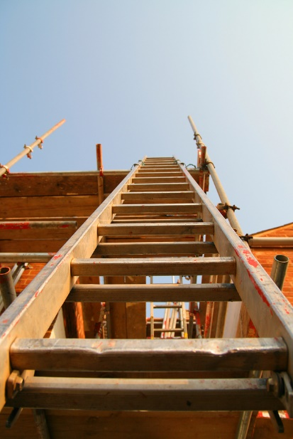
Ladders must be selected based on hazards and tasks. Also, ladders require maintenance in order to function properly. Each ladder type requires different inspection criteria and maintenance. If a ladder is neglected, it may become unsafe to use. For this reason, it is extremely important that ladders are inspected prior to each use and repaired periodically.

Types of ladders:
- Length:
  - Stepladder users must be able to reach about four feet from the top of the ladder while standing on the second step from the top.
  - Extension ladders must be 7 – 10 feet longer than the vertical distance to the highest contact point on a structure.
  - Materials:
    - Wood ladders are solidly constructed of straight grain materials and free from defects. Side rails must be perfectly smooth and free from slivers. Wood ladders provide insulation against heat and cold, but tend to age quickly when left untreated.
    - Metal ladders must be of sufficient cross-section strength to prevent extreme deflection when in use. Rungs are corrugated, coated with skid-resistant materials, or otherwise treated to minimize slipping.
    - Metal and aluminum ladders are marked to warn against use around electricity.
    - Aluminum ladders are lightweight and resistant to corrosion; however, they conduct electricity and do not insulate against heat or cold.
    - Fiberglass ladders are weather-resistant, durable, and non-conductive when clean and dry. These ladders are very heavy and tend to chip and crack when handled improperly.
  - Duty Rating:
- Light Duty (III): 200 pounds
- Medium duty (II): 225 pounds
- Heavy duty (I): 250 pounds
- Extra heavy duty (I-A): 300 pounds
- Special duty (IAA): 375 pounds
- Never use a ladder for more than its intended duty.

Inspect ladders for:
- Loose, split, cracked, or missing rungs.
- Lost or damaged feet—if the ladder is equipped with them.
- Any signs of rot on wood ladders.
- Cracks on any sections such as the rails and steps.
- Loose, missing, or damaged parts.
- Repairs and assure they meet the original design criteria.
- Oil, grease, and other potential slipping hazards.
- Weathering, fiber bloom, cracks, and other defects on fiberglass ladders.
General maintenance:
- Inspect your ladder prior to each use.
- Clean and lubricate moving parts.
- Replace worn parts and labels according to the manufacturer’s instructions.
- Keep ladders away from heat sources and corrosive substances.
- Assure that all rungs are parallel, level, and uniformly spaced.
- Take damaged ladders out of service, and mark “Do Not Use”. If ladders are taken out of service, assure they are destroyed to prevent further use.
- Use ladders only for their intended purpose.
- Periodically treat wooden ladders with a clear preservative such as varnish, shellac, or linseed oil.
- Do not paint wooden ladders—paint can conceal structural defects.
- Replace lower steps on wooden ladders when the step’s surface is worn.
- Clean metal ladder rungs to prevent accumulation of materials that might destroy non-slip properties. Carefully check all metal fittings.
- Store ladders under suitable cover for protection from the weather.
- Support horizontally stored ladders at both ends as well as the intermediate points to prevent sagging, which will loosen the rungs and warp the rails.
- Prohibit employees from using damaged ladders.

This form documents that the training specified above was presented to the listed participants. By signing below, each participant acknowledges receiving this training.

Organization: Date:

Trainer: Trainer’s Signature:

Class Participants:

Name: Signature:

Name: Signature:

Name: Signature:

Name: Signature:

Name: Signature:

Name: Signature:

Name: Signature:

Name: Signature:

Name: Signature:

Name: Signature:

Name: Signature:

Name: Signature:

Name: Signature:

Name: Signature:

Name: Signature:

Name: Signature:

