Department of Transportation (DOT) Placards indicate the presence of hazardous materials inside containers.

- Any employer receiving packages or containers of hazardous materials which are required to be marked, labeled or placarded in accordance with the U. S. Department of Transportation (DOT) Hazardous Materials Regulations needs to retain those markings, labels and placards on the package or container.
- Employees who work with these materials need to be familiar with their meaning and ensure they have had proper hazard communication training prior to working with any chemical. Pay particular attention to the class number on the bottom corner of each diamond as it indicates the DOT class and related hazards.

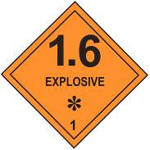
Class 1--Explosives: Includes substances that present an
explosive hazard such as fireworks or blasting agents.

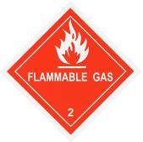

Class 2--Gases: Includes compressed gases such as propane, acetylene or gaseous nitrogen.

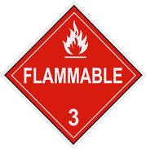

Class 3--Flammable liquids: Includes flammable (and combustible) liquids such as acetone or toluene.

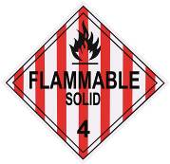
Class 4--Flammable solids: Includes flammable solids such as sodium or potassium and water reactive substances.

Class 5--Oxidizing substances and Organic peroxides: Includes substances that yield oxygen such as hydrogen peroxide.
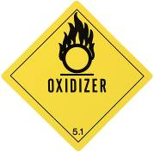
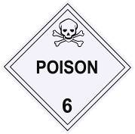
Class 6--Toxic and infectious: Includes substances that are biohazardous or poisonous chemical solvents such as carbon tetrachloride.

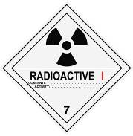
Class 7--Radioactive: Includes substances that are radioactive, such as isotopes used for experimental purposes.

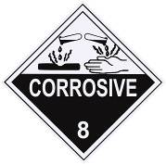
Class 8--Corrosive subtances: Includes liquids that can burn skin or dissolve metal. Examples include sodium hydroxide or hydrochloric

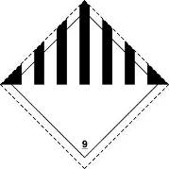

Class 9--Miscellaneous hazardous materials, products, substances or organisms: Includes miscellaneous materials that do not meet the definition of any other hazard class. Examples include dry ice or lithium batteries.

This form documents that the training specified above was presented to the listed participants. By signing below, each participant acknowledges receiving this training.

Organization: Date:

Trainer: Trainer’s Signature:

Class Participants:

Name: Signature:

Name: Signature:

Name: Signature:

Name: Signature:

Name: Signature:

Name: Signature:

Name: Signature:

Name: Signature:

Name: Signature:

Name: Signature:

Name: Signature:

Name: Signature:

Name: Signature:

Name: Signature:

Name: Signature:

Name: Signature:

