Objective: To understand why GFCI protection is an important safety consideration.

When an electrical device is plugged into an outlet, it completes an electrical circuit that powers the device. If anything causes the circuit to become imbalanced—that is, the plugged-in device conducts more electricity than it needs—it can put the device’s user at risk of electric shock, unless it is plugged into a ground fault circuit interrupter.
What does a ground fault circuit interrupter do?
Ground faults can occur when electricity finds a path between its current to a conductive surface. This can cause burns, shocks, electrocutions, and fires.
A ground fault circuit interrupter, or GFCI, is a device that detects the potential for ground faults based on circuit imbalances: if the “outgoing” current—the current traveling from the outlet to the connected device—outweighs the “incoming” current—the current returning to the outlet—by 5 milliamperes or more, the GFCI will immediately break the circuit.
What can cause a ground fault?
Electricity is always trying to find a path towards a grounded surface. When it comes to tool use, that often means finding its way from the circuit to the body of the individual using the tool. This can occur when there is:
- Frayed or faulty wiring
- Worn insulation
- Tools with metal casing
- Lack of insulating protective equipment

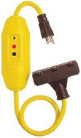
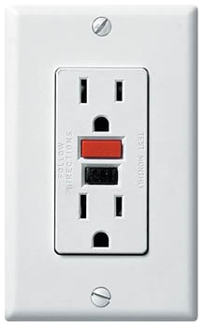
Where will I find GFCIs?
GFCIs may be integrated into permanent outlets, such as the one seen in Figure 1, or part of portable devices, such as extension cords, as seen in Figure 2.
Due to the conductive properties of water, GFCIs are commonly installed in areas subject to wet, damp, or humid working conditions, such as basements, bathrooms, kitchens, and outdoor spaces.
Fig. 1 | Fig. 2
GFCIs and Construction
On construction sites, OSHA requires the use of GFCI devices (either temporarily installed receptacle devices or extension cords with GFCI attachments) with all 120-volt, single-phase 15- and 20-ampere outlets that are not part of the site’s permanent wiring.
Testing and Maintenance:
GFCIs should be regularly tested to ensure their proper functionality. The safest way to do so is via a GFCI tester, which can be plugged into the outlet or GFCI device and simulates a circuit imbalance.
Regular testing and maintenance of tools and other powered devices is also important to minimize the potential for creating a ground fault.

This form documents that the training specified above was presented to the listed participants. By signing below, each participant acknowledges receiving this training.

Organization: Date:

Trainer: Trainer’s Signature:

Class Participants:

Name: Signature:

Name: Signature:

Name: Signature:

Name: Signature:

Name: Signature:

Name: Signature:

Name: Signature:

Name: Signature:

Name: Signature:

Name: Signature:

Name: Signature:

Name: Signature:

Name: Signature:

Name: Signature:

Name: Signature:

Name: Signature:

