Potential hazards of confined spaces:
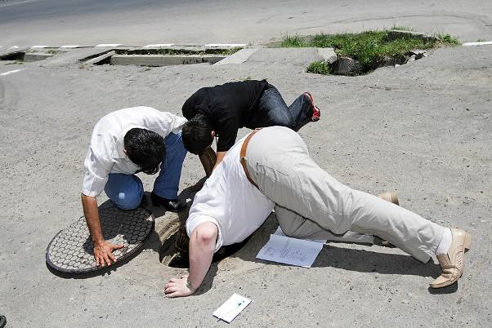
- Toxic fumes
- Oxygen deficiency
- Explosive atmosphere
- Exposure to hazardous energies
- Moving machine parts
- Engulfment/entrapment
Safety precautions:
- Perform a hazard assessment: Identify all hazards and needed controls. Include hazards created by the work itself.
- Get a confined space permit signed by a confined space entry supervisor.
- Monitor air:
- Provide initial and continuous monitoring for toxics, flammables, and oxygen.
- Ventilate and monitor when performing hot work or applying chemicals either in a confined space or an adjacent area.
- Check for adequate, continuous ventilation when hazardous atmospheres are possible.
- Lock-out all energy sources: This includes stored energies.
- Use proper controls and protective equipment: This includes respiratory, skin, eye, and fall protection.
- Set up a retrieval device.
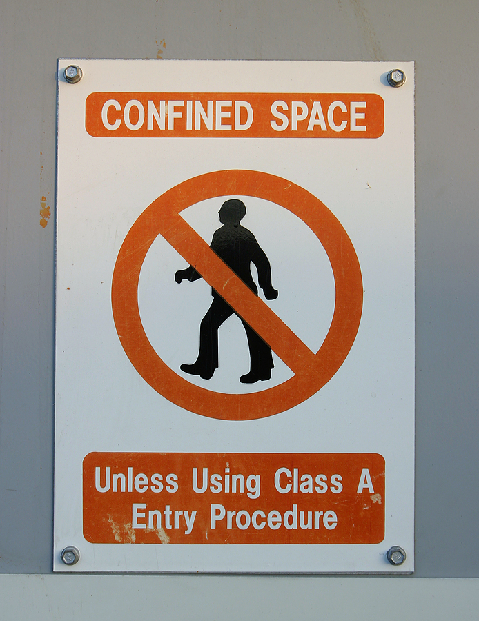
- Confirm that training is current for:
- Entry personnel
- Attendants
- Supervisors
- Rescue personnel
- Ensure that rescue personnel are available.
- Ensure that the attendant is:
- At the point of entry.
- In communication with rescue and entry personnel.
- Know how to prevent heat stress:
- Take breaks as needed in a cool environment.
- Drink fluids.

This form documents that the training specified above was presented to the listed participants. By signing below, each participant acknowledges receiving this training.

Organization: Date:

Trainer: Trainer’s Signature:

Class Participants:

Name: Signature:

Name: Signature:

Name: Signature:

Name: Signature:

Name: Signature:

Name: Signature:

Name: Signature:

Name: Signature:

Name: Signature:

Name: Signature:

Name: Signature:

Name: Signature:

Name: Signature:

Name: Signature:

Name: Signature:

Name: Signature:

