Objective: To assure that employees understand the importance of a safe following distances and how to maintain a safe distance

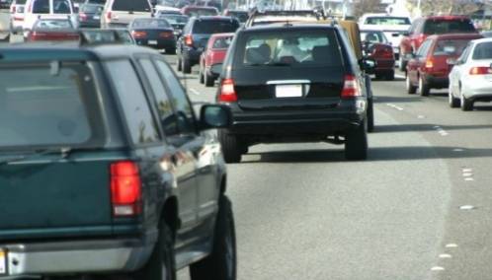
In the rush and anxiety of everyday driving, following distance is often sacrificed for getting somewhere faster. However, when you do not allow enough following distance, you not only put yourself at risk, you fail to save time and may cause further slowing of traffic.
Determining a Safe Following Distance
- Determine an appropriate distance from the car in front of you, using one of the following methods.
  - To use the three-second rule, select a fixed object along the roadway, and assure that it takes at least three seconds for your vehicle to pass it from the time the vehicle in front of you passes it.
  - To use the car-length method, maintain a distance of at least one car-length for every 10 mph.
- Create an additional cushion of space between your vehicle and the vehicle in front of you. The benefits of having a safety cushion include:
  - Giving drivers time to recognize and react to changes or emergencies on the road
  - Allowing cars to change lanes and make turns without interrupting the flow of traffic
  - Keeping traffic moving
- In certain conditions, add additional distance:
- In wet, slick, or other inclement weather conditions
- At night or in other low-visibility conditions
- When following a motorcycle
- If being followed by a bus or semi
- If pulling a trailer
- If being tailgated

This form documents that the training specified above was presented to the listed participants. By signing below, each participant acknowledges receiving this training.

Organization: Date:

Trainer: Trainer’s Signature:

Class Participants:

Name: Signature:

Name: Signature:

Name: Signature:

Name: Signature:

Name: Signature:

Name: Signature:

Name: Signature:

Name: Signature:

Name: Signature:

Name: Signature:

Name: Signature:

Name: Signature:

Name: Signature:

Name: Signature:

Name: Signature:

Name: Signature:

