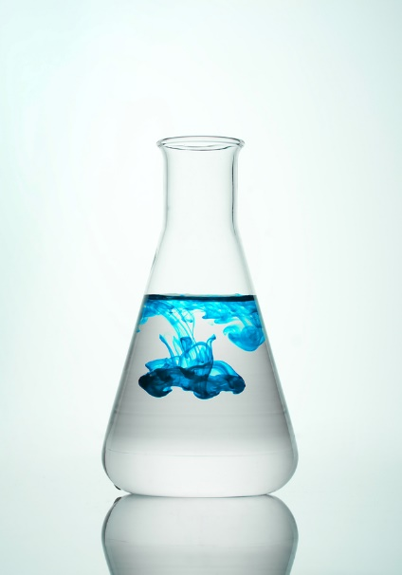
Acids and bases are chemicals that can easily damage your skin and eyes. The severity of the hazard depends on how strong the chemical is, how long contact is maintained and what actions you take after contact is made.
Acids and bases can be liquids, granules, powders, vapors or gases. Acids are defined as having a pH less than 7, while bases have a pH greater than 7. Water is neutral and has a pH of 7. Acids and bases are often used for their effectiveness in cleaning and stripping paints or stains, as well as many other industrial applications. A few commonly used acids are: sulfuric acid, hydrochloric acid, muriatic acid and nitric acid. Two common bases are lye (sodium hydroxide) and caustic potash (potassium hydroxide).
Health effects:
Concentrated acids and bases can dissolve tissue easily and therefore cause severe skin and eye damage on contact. Concentrated, caustic gases like ammonia vapors can damage the skin, eyes, nose, mouth and lungs. When inhaled, even dry, powdered, bases can cause damage, because they react with the moisture in your skin, eyes and respiratory tract.
Proper Handling:
- Work with acids and bases in well-ventilated areas or with devices that remove the hazard, such as local exhaust ventilation, fume hoods or similar capture devices.
- Work with small quantities.
- Work with acids and bases in designated locations.
- Never work alone.
- Always add acid to water to prevent splattering from overheating and boiling.
- Clean-up spills promptly with appropriate materials.
- Keep acids and bases apart by storing them separately in proper containers and storage cabinets.
- You must be trained on how to read the container label and safety data sheet (SDS) information, including the location, proper handling and emergency procedures.
- You must be trained on the hazards of each chemical before working with it.

Personal protective equipment:
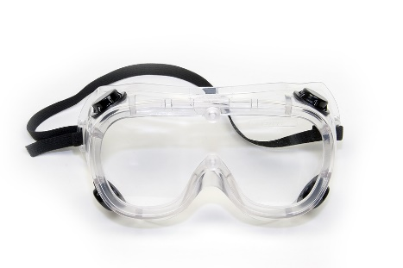
- Use personal protective equipment (PPE) as required.
- A hazard assessment must be conducted to determine appropriate PPE based on specific chemicals and processes.

- Eye protection must be worn when working with liquid acids and bases; goggles must be worn if caustic vapors are present.
- Face protection, such as a face shield, is required when working with large volumes of liquid acids and bases.
- An apron or disposable gown must be worn when working with large volumes of liquid acids and bases.
- Acid-resistant gloves must be worn when handling acids and bases. Refer to the SDS to choose appropriate gloves for each acid and base.
- Latex, natural rubber: General purpose gloves with protection from most acids and bases.
- Butyl gloves: Gloves providing protection from strong acids, such as sulfuric and nitric acid, and bases.
- Nitrile: Gloves providing protection against most acids and bases.
- Neoprene: Gloves with protection from organic acids, which are more tear-resistant than latex gloves.

Emergency response:
- A spill kit must be available near work with acids and bases that includes:
- Absorbent materials.
- Neutralizing powders or liquids, such as baking soda (sodium bicarbonate), for acid spills.
- For base spills, diluted vinegar (acetic acid) or similar diluted acid.

- Additional chemical-resistant gloves, aprons or gowns, eye protection and other PPE.
- Know how to clean up spills of the acids and bases you are working with.
- Know where the eyewash and safety shower are located and how to use them properly.
.

First aid:
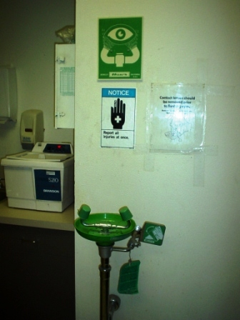
- In case of skin or eye contact, flush with cool water for at least 15 minutes, but do not rub the skin or eyes.
- If a large volume of liquid is splashed on clothing, remove clothing and use the safety shower for 15 minutes.
- If ingestion occurs, contact your local poison control.
- Refer to the SDS for additional first aid procedures.
- Contact emergency response professionals for further guidance.
- Your first aid kit must contain:
- Calcium gluconate gel based materials for the topical treatment of hydrofluoric acid.
- Additional PPE for the first aid provider.
- Additional first aid supplies for specific acids and bases.

Acids and bases are hazardous chemicals that need special attention. Ensure that all the proper control measures and emergency response equipment is available for your specific chemical hazards.

This form documents that the training specified above was presented to the listed participants. By signing below, each participant acknowledges receiving this training.

Organization: Date:

Trainer: Trainer’s Signature:

Class Participants:

Name: Signature:

Name: Signature:

Name: Signature:

Name: Signature:

Name: Signature:

Name: Signature:

Name: Signature:

Name: Signature:

Name: Signature:

Name: Signature:

Name: Signature:

Name: Signature:

Name: Signature:

Name: Signature:

Name: Signature:

Name: Signature:

