Objective: To familiarize employees with common types of hand and arm protection and best practices for their use.

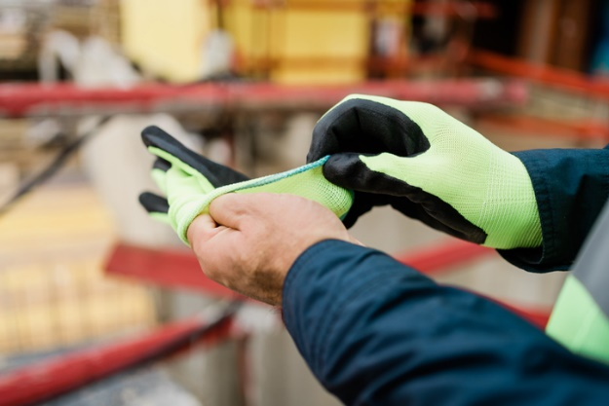
Your hands can be subject to numerous potential injuries at work, especially when working with chemicals, extreme hot or cold temperatures, and sharp, heavy, or abrasive objects and surfaces. Make sure you use the appropriate level of hand and arm protection to minimize your chances of injury.

Common Hazards that Require Hand Protection

Workplace hazards that could cause injury to the hand include:
- Splashes or exposures from chemicals, liquids, or molten materials
- Punctures, cuts, and abrasion hazards from sharp objects.
- Extreme temperatures
It’s important to select gloves that protect the wearer from hazards, but still allow for dextrous movements.
- Repetitive motion or vibration
- Energized electrical equipment.

Common Types of Gloves

Protective gloves are available in a variety of materials to protect against various hazards.
Material | Protects Against
Fabric/Cotton | Light duty material handling and cleanup work
Leather | Equipment handling, general construction, heavy cleanup, welding, moderately hot or cold material handling
Shock absorbing | Operating rotary hammers and other vibrating equipment
Kevlar or wire mesh | Work with sheet metal, glass, or heavy cutting. DO NOT provide puncture protection.
Nitrile, neoprene, PVC, PVA, & other synthetics | Industrial jobs and protection against some chemicals
Insulated | Extreme high or low temperatures
Viton | Chlorinated and aromatic solvents
Butyl rubber | Aldehydes, ketones, and esters
Neoprene | Solvents, acids, caustics, and alcohols
Natural rubber (latex) | Acids and caustics
Polyvinyl Chloride | Acids, but not solvents

Selection Criteria
When selecting gloves and arm protection, consider the following:
- Tasks being performed
- Conditions in the work area
- Duration and frequency of use
- Grip and manual dexterity needed
- Puncture and cut resistance needed
- Chemical resistance
- All other potential hazards
Gloves come in many sizes, and it’s important to select those with the proper fit. Too loose of a glove can be an entanglement hazard or potentially expose you to hazardous chemicals. A glove that is too tight can decrease hand circulation, causing the wearer to lose dexterity.
Remember: No one type of glove protects against all hazards!
Hand Protection Best Practices
Hand protection is critical in conjunction with other PPE to keep the user safe at work.

- Prior to each use, inspect gloves for:
  - Holes or other signs of wear.
  - Discoloration or stiffness resulting from manufacturing flaws.
- If using disposable gloves, verify they have not been previously worn before use.
- Do not use gloves that show defects or excessive wear. Replace defective or excessively worn gloves as needed.
Choose the appropriate glove length for the hazards you work with. The length should sufficiently protect the wearer from chemical splashes or from immersion hazards.

- When work is complete, take appropriate precautions when removing gloves to avoid exposure to hazardous materials.
  - When appropriate, wash gloved hands before removing gloves.
  - Pull the gloves’ cuffs over your hand to remove them from the inside out.
- Store or dispose of gloves properly after each use.
- Wash your hands after disposing of gloves.

This form documents that the training specified above was presented to the listed participants. By signing below, each participant acknowledges receiving training on the abovementioned subject. They understand that this training was only a general overview of the subject and that they should contact their supervisor with any questions or concerns.

Organization: ________________________ Date: _________________________________

Trainer: ___________________________ Trainer’s Signature: _____________________
Class Participants:

Name: _____________________________ Signature: ________________________________
Name: _____________________________ Signature: ________________________________
Name: _____________________________ Signature: ________________________________
Name: _____________________________ Signature: ________________________________
Name: _____________________________ Signature: ________________________________
Name: _____________________________ Signature: ________________________________
Name: _____________________________ Signature: ________________________________
Name: _____________________________ Signature: ________________________________
Name: _____________________________ Signature: ________________________________
Name: _____________________________ Signature: ________________________________
Name: _____________________________ Signature: ________________________________
Name: _____________________________ Signature: ________________________________
Name: _____________________________ Signature: ________________________________
Name: _____________________________ Signature: ________________________________
Name: _____________________________ Signature: ________________________________
Name: _____________________________ Signature: ________________________________
Name: _____________________________ Signature: ________________________________
Name: _____________________________ Signature: ________________________________
Name: _____________________________ Signature: ________________________________
Name: _____________________________ Signature: ________________________________
Name: _____________________________ Signature: ________________________________

