Proper instruction & information is critical:
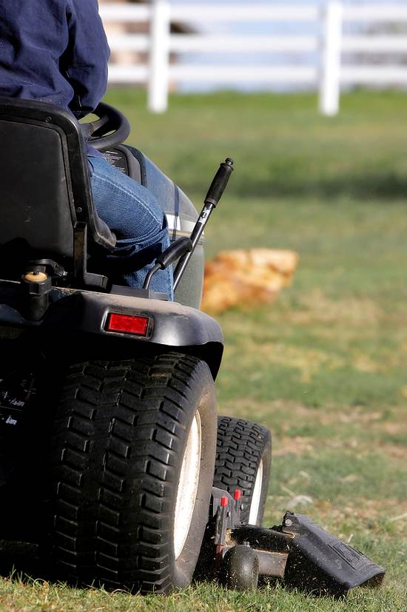
Do not use any lawn mower without proper instruction. Only trained operators are allowed to use the lawn mowers. Proper training must include a review of the operator’s manual, as well as a skills evaluation to assure that the operators understand the features of this piece of equipment and can use it safely.
Hazards:
Many hazards are involved when using a lawn mower, including:
- Flying particles of dirt or debris, or other particles discharged from the cutting deck.
- Slopes, uneven, or unstable ground that could potentially result in rollovers or other unsafe conditions.
- Objects in the path of travel can damage equipment or become projectiles when struck.
- Exposure to outdoor environments including insects, sun, and allergens.
- Noise exposure.
- Exposure to exhaust gases such as carbon monoxide in poorly ventilated areas.
- Burns from the exhaust system.
- Exposure to mechanical hazards from the blades and other moving parts.
Prior to use:
Inspect and test the equipment based on the manufacturer’s requirements before each use to assure that the safety devices are working. All guards must be in place and the equipment must be in good, ready-to-use condition. If the equipment is equipped with roll over protection or a seatbelt, it must be functional and used. Follow the manufacturer’s recommendations for proper scheduled maintenance. Complete a written field inspection form to document that the equipment is suitable for use.

Required PPE:

When conditions dictate a hazard is present, the following personal protective equipment (PPE) is required based on the presence of the hazard.
    - Body: Long-sleeved shirt and long-legged pants without loose areas that could create a pull-in hazard.
    - Feet: Anti-slip, enclosed, ankle-height, leather boots.
    - Eyes: Safety glasses with side shields or wrap around lenses; can be appropriately shaded.
    - Ears: Ear plugs or muffs when operating or around noisy equipment.
Optional PPE:

PPE is not required based on the hazard but employee chooses to use/wear for extra protection or comfort.
    - Head: Hard hats must be worn when working below overhead hazards such as low branches. A sunhat for protection is also advised.
    - Body: Rain gear is recommended during wet weather.
    - Feet: Rubber boots in wet conditions.
    - Face: Face shield may be required when splashing or flying particles are likely. Goggles or safety glasses must be worn underneath a face shield. Goggles must be worn for liquid hazards and safety glasses for solids or particulate hazards.
    - Hands: Leather, faced-cotton, or synthetic, nitrile gloves may be worn for chemical exposures. Do not use gloves around moving machine parts due to pull-in hazard.
    - Lungs: Respirator; a disposable dust mask can be used on a voluntary basis.
Lockout and tagout:

Use isolation or other protection as needed to isolate energy sources such as gravity, springs, and pneumatics or hydraulics. If you’re not qualified to make appropriate repairs using safe work practices, contact an authorized and qualified equipment mechanic.
Operating equipment:
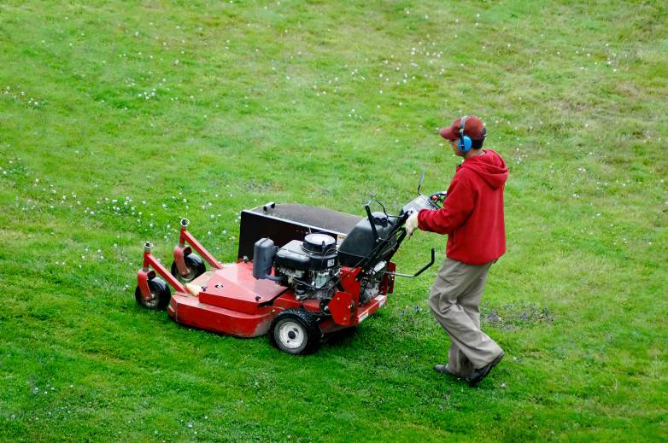
- Equipment operators must be trained and qualified to operate each of the different types of lawn mowers that they may be asked to use. Training must be documented and kept on file. Before mowing an area, the equipment operator must make sure the area to be mowed is clear of people and hazards. Hazards may include uneven or soft terrain, holes, foreign objects, sprinkler heads and any other type of obstruction they may encounter (roots, hoses, cords, etc.).
- Lawn mowers may not be left unattended. Engines and any other power take-off or drives shall be shut off before the operator gets off the mower. Mowers must be disengaged when moving from one job to the next and when passing over curbs, gravel, or similar surface.
- Mower blades cutting-height must not be set too low creating contact with rock or soil, typically lower than one inch.
- Mowing hills and slopes requires the operators to follow special precautions and manufacturer instructions as to use and limitations of the equipment. A pre-survey and approach needs to be established. All hills, slopes, and banks that exceed the safe operating limit of the equipment must be mowed with a walk-behind mower in accordance with the equipment’s safe operating instructions.
- Mow in daylight, but be mindful of the signs and symptoms of heat stress. Take frequent breaks and drink plenty of water.
- If blade inspection or any type of repair or cleaning is needed during work, shut off the mower and assure the blade has stopped rotating. Disconnect the spark plug wire or unplug the power cord to assure the mower will not start while hands are near moving parts. Avoid touching hot parts.
- When refueling gas-powered lawn mowers, make sure the engine is not running or hot. Fuel outdoors at least 20 feet from any possible ignition source. Move well away from the fueling location and its lingering fuel vapors before starting up the mower. Wipe up any spilled gasoline immediately.
- Do not over-fill the gas tank or over-tighten the gas cap after refueling.
- When using an electric mower, mow away from the cord. Always use a grounded cord that is not frayed with a grounded three prong outlet.
- Do not use an electric mower in rain or other wet conditions
Safety tips for walk-behind lawn mowers:
- Do not tilt the mower. Keep four wheels on the ground while operating the mower.
- On slopes, mow across to minimize risk of injury if you slip. Use proper anti-slip soled shoes.
Safety tips for riding lawn mowers:
- Assure the transmission is disengaged before you start the engine.
- Do not allow anyone else to ride on the mower with you.
- Do not mow in reverse unless it is absolutely necessary and the operator’s manual indicates it can be done. If mowing in reverse, look before moving backwards to assure no person or obstacle is in your path.
- To avoid a rollover, do not ride the mower on an incline that is too steep, but ride the mower up and down reasonable slopes. Do not ride across slopes.
- Slow down when turning on slopes or whenever turning sharply so as not to tip over.
- When done with the work, turn off the engine and wait for the blades to stop turning. Safely dismount and remove the key.

This form documents that the training specified above was presented to the listed participants. By signing below, each participant acknowledges receiving this training.

Organization: Date:

Trainer: Trainer’s Signature:

Class Participants:

Name: Signature:

Name: Signature:

Name: Signature:

Name: Signature:

Name: Signature:

Name: Signature:

Name: Signature:

Name: Signature:

Name: Signature:

Name: Signature:

Name: Signature:

Name: Signature:

Name: Signature:

Name: Signature:

Name: Signature:

Name: Signature:

