**Objective:** To increase awareness of the health risks and prevention methods associated with Hepatitis A.

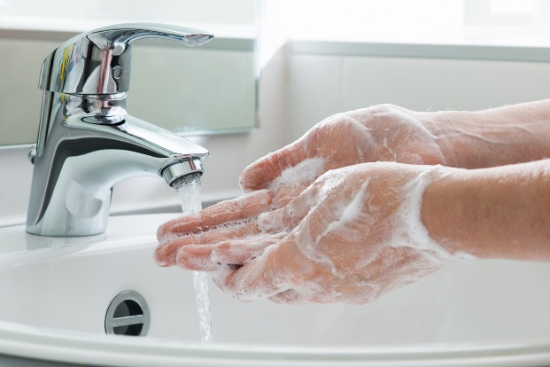**Understanding the Dangers**

Hepatitis A is a contagious, inflammatory liver disease caused by a virus typically spread through contact with contaminated surfaces or food. The culprits include poor sanitation, contaminated drinking water, poor personal hygiene, and sexual contact.

Hepatitis A isn’t a chronic infection. The disease typically incubates 14-28 days. Most infected people recover from the infection without lasting liver damage and develop immunity to future infection. However, on rare occasions, some people develop severe symptoms or liver issues that may become fatal.

**Transmission**

*Using proper handwashing and sanitation practices can help prevent the spread of Hepatitis A.*

Hepatitis A is spread via the fecal-oral route, which involves touching surfaces containing the virus or ingesting something contaminated by an infected person's feces. It’s most often spread through close contact with an infected member of the person’s household or sex with an   
infected partner.

The Hepatitis A virus exists in numerous environments and can even survive certain food production processes.

Public outbreaks of Hepatitis A often involve fruits, vegetables, shellfish, ice, and water.

**Symptoms**

Adults are more likely to show symptoms than younger children. However, some adults may be asymptomatic. Common symptoms include:

* Fever
* Nausea and vomiting
* Dark-colored urine
* Jaundice
* Loss of appetite
* Abdominal pain

There are no specific treatments for people who develop Hepatitis A infection other than rest, good hydration and nutrition, and avoiding drugs and alcohol, which can cause additional liver damage.

**Prevention**

Getting the Hepatitis A vaccination will prevent you from developing the disease. Other precautions include:

* Frequently handwashing with soap and water after using the bathroom or changing diapers.
* Washing hands well prior to preparing food, especially for food handlers.
* Properly sanitizing food-contact surfaces. To do this, first remove debris, clean the surface with an effective detergent, and rinse the object with clean, extremely hot water or place it in a dishwasher.
* Cooking food or boiling water at temperatures high enough to kill the virus (185° F for at least one minute). **Note:** Freezing temperatures won’t destroy the virus.
* Washing food, especially fruits, vegetables, and shellfish, prior to eating them.

This form documents that the training specified above was presented to the listed participants. By signing below, each participant acknowledges receiving this training.

Organization: Date:

Trainer: Trainer’s Signature:

**Class Participants:**

Name: Signature:

Name: Signature:

Name: Signature:

Name: Signature:

Name: Signature:

Name: Signature:

Name: Signature:

Name: Signature:

Name: Signature:

Name: Signature:

Name: Signature:

Name: Signature:

Name: Signature:

Name: Signature:

Name: Signature:

Name: Signature:

Name: Signature:

Name: Signature:

Name: Signature:

Name: Signature:

Name: Signature: