**Objective:** To familiarize employees with common types of foot protection.

Keeping your feet safe on the job means protecting them from a range of potential hazards, including skin infections, crushing injuries, exposure to electricity, chemicals, extreme temperatures, sharps, and other common worksite hazards. Before beginning work, conduct a job hazard analysis to determine if foot protection is needed to prevent injury.

**Purchasing Requirements**

While employers are required to supply most personal protective equipment, there are exceptions for non-specialty safety toe shoes. Per the U.S. Occupational Safety and Health Administration’s (OSHA) Personal Protective Equipment Standard, 29 CFR 1910.132(h)(2):

*The employer is not required to pay for non-specialty safety-toe protective footwear (including steel-toe shoes or steel-toe boots) and non-specialty prescription safety eyewear, provided that the employer permits such items to be worn off the job site.*

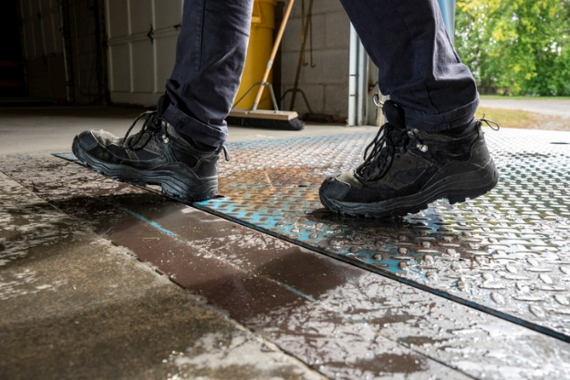**Common Hazards that Require Foot and Leg Protection**

Workplace hazards that could cause injury to the feet and legs include:

* Falling objects
* Splashes or exposures from chemicals, liquids, or molten materials
* Flying debris from tool or equipment use
* Piercing, cut, and abrasion hazards from sharp objects.
* Wet surfaces
* Hot surfaces
* Energized electrical equipment.

*While safety shoes offer certain protections, it’s important to always be aware of your surroundings and changing surface conditions.*

**Common Types of Safety Shoes**

Safety shoes are designed to protect your feet against crushing injuries and typically include reinforced steel toe boxes. Common specialized models of safety shoes include the following:

* **Electrically Conductive:** For use in environments with high static electricity, these shoes reduce the risk of sparks from buildings in explosive or hazardous locations.
* **Foundry:** For use in heat-producing environments, these shoes insulate the feet against heat from molten metal.
* **Electrical Hazard Non-Conductive Shoes:** For use in areas with electrical hazards, these shoes protect the worker from shock by preventing them from becoming part of the electrical current path.
* **Metatarsal Protection:** For use in many different material handling environments, these offer protection at the top of the foot as well as the toe.
* **Chemical-Resistant:** For use in areas with hazardous chemicals and biological agents, chemical-resistant shoes offer protection to the user from splashes or spills of material.
* **Slip-Resistant:** For use in environments with wet or slick floors, these shoes offer protection against slips, trips, and falls.

**Other Forms of Foot Protection**

* Attachable guards that protect the top and sides of the foot
* Rubber shoes and foot coverings
* Shoes with specialized soles, such as wooden or slip-resistant
* Shoe liners
* Disposable fabric shoe covers
* High-performance socks, such as thermal or moisture-wicking

**Leg Protection**

Leg protection may be necessary in certain workplaces when splashes, sparks, debris, or environmental conditions may prove hazardous. Examples include:

* **Leg guards or leggings:** Offer protection to the knee, shin, and top of the foot; typically used in hot work environments.
* **Waders:** Offer protection to the lower body, typically used in wet environments.
* **Chaps:** Offer protection to the upper and lower legs; typically used in welding or chainsaw operations.

**Selection Criteria**

When selecting foot and leg protection, it is critical to find the appropriate fit, coverage, and material. Employees should understand the protective nature of the clothing and the limits to its functionality.

* Look for shoes with an American Society for Testing and Materials (ASTM) F2413 standard rating when selecting protective footwear.
* Choose an appropriate sock to fit comfortably inside the shoe.
* The type of upper material and sole will depend on the type of hazards in the workplace.
* If wearing steel-toe shoes, the cap of the steel toe should offer appropriate protection along the length of the toes.

***Remember:*** *No shoe is fully slip-proof! Clean up spills as they occur and practice good housekeeping.*

**Foot & Leg Protection Best Practices**

Foot and leg protection is critical in conjunction with other PPE to keep the user safe at work.

* Inspect foot and leg protection for holes, cuts, lodged objects, or other noticeable signs of wear.
* Replace any worn or damaged articles.
* Regularly check the tread of the shoe.

*Consider keeping dry clothes and socks available to change into when working in wet environments.*

This form documents that the training specified above was presented to the listed participants. By signing below, each participant acknowledges receiving training on the abovementioned subject. They understand that this training was only a general overview of the subject and that they should contact their supervisor with any questions or concerns.

**Organization:** ________________________ **Date:** _________________________________

**Trainer:** ___________________________ **Trainer’s Signature**: _____________________

**Class Participants:**

Name: _____________________________ Signature: ________________________________

Name: _____________________________ Signature: ________________________________

Name: _____________________________ Signature: ________________________________

Name: _____________________________ Signature: ________________________________

Name: _____________________________ Signature: ________________________________

Name: _____________________________ Signature: ________________________________

Name: _____________________________ Signature: ________________________________

Name: _____________________________ Signature: ________________________________

Name: _____________________________ Signature: ________________________________

Name: _____________________________ Signature: ________________________________

Name: _____________________________ Signature: ________________________________

Name: _____________________________ Signature: ________________________________

Name: _____________________________ Signature: ________________________________

Name: _____________________________ Signature: ________________________________

Name: _____________________________ Signature: ________________________________

Name: _____________________________ Signature: ________________________________

Name: _____________________________ Signature: ________________________________

Name: _____________________________ Signature: ________________________________

Name: _____________________________ Signature: ________________________________

Name: _____________________________ Signature: ________________________________

Name: _____________________________ Signature: ________________________________