**"Behavior Based Safety" (BBS)** can have positive results when done correctly. In a successful BBS approach, everyone must be on the same page with respect to what the safe behaviors are for all hazards present.

*To assure everyone is truly aware of the hazards and respective controls for each task, a simple process can be employed… Job Hazard Analyses (JHAs).*

* JHAs provide a simple outline of the CRITICAL BEHAVIORS which need to be followed to assure safe performance. They outline for the tasks of a job, the respective hazards, and for those hazards, the respective critical behaviors required to prevent an incident. Developing JHAs is the first step in an effective BBS approach. Coupled with excellent training and observations, a true safety culture can be developed.
* JHA development begins by performing hazard assessments. The JHA must identify both the hazards of the tasks, and the needed critical behaviors to prevent an unwanted outcome.
* 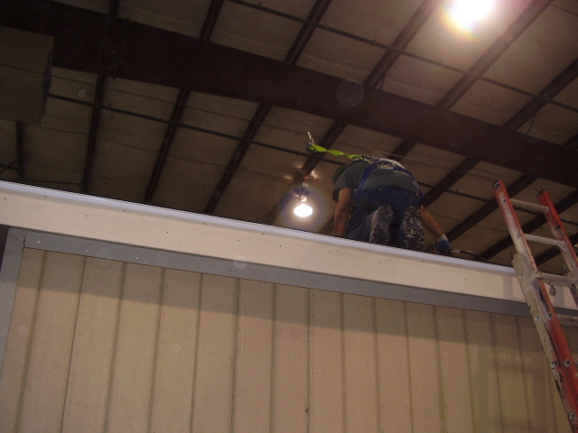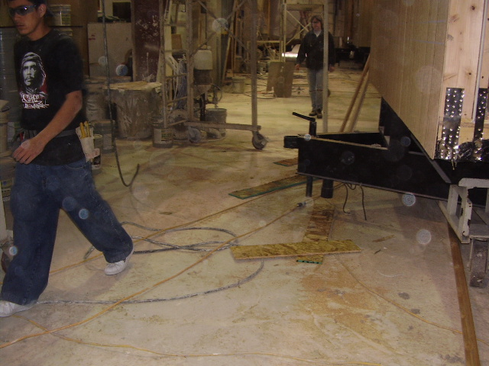Following is a Hazard Assessment Form which can assist in evaluating tasks, hazards and needed controls. When using the form, look for any unsafe conditions, talk to and observe staff to see what critical behaviors are needed to prevent a mishap, as well as any situations that cause employees to make unsafe choices (e.g., locking out a piece of equipment is required but necessary supplies are not available in the area).

**Fall Protection needed and used** **Housekeeping issues – unsafe acts lead to unsafe conditions**





This form documents that the training specified above was presented to the listed participants. By signing below, each participant acknowledges receiving this training.

Organization: Date:

Trainer: Trainer’s Signature:

**Class Participants:**

Name: Signature:

Name: Signature:

Name: Signature:

Name: Signature:

Name: Signature:

Name: Signature:

Name: Signature:

Name: Signature:

Name: Signature:

Name: Signature:

Name: Signature:

Name: Signature:

Name: Signature:

Name: Signature:

Name: Signature:

Name: Signature: