**Take protective measures when there is a chance of falling or moving objects.**

Falling or moving objects disable more than 260,000 workers a year. Of every 100 workers hurt, 14 are struck by something falling or moving. Wearing the right Personal Protective Equipment (PPE) can help workers avoid this kind of accident. In order to determine the appropriate PPE, complete a Hazard Assessment for all tasks performed. This will also identify exposures and needed controls.

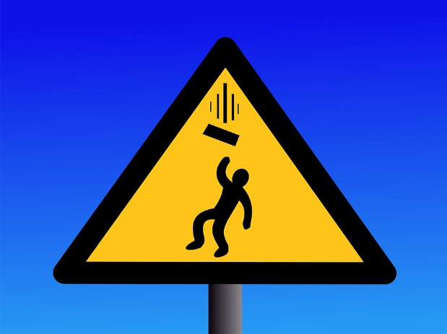

**Basic PPE:**

* **Safety glasses:** When the job calls for them, always wear safety glasses. These must be:
* Approved by the American National Standards Institute (ANSI).
* Equipped with side shields.
* Kept clean.
* Checked for proper fit.
* Supplemented with additional eye protection when required by the Hazard Assessment.
* **Hard hats:** Head protection is a must on certain jobs, especially around overhead work or where there might be falling objects.
* **Safety shoes:** Ensure that your shoes are capable of protecting your toes from falling or rolling objects.
* Additional protection may be needed, such as metatarsal guards, if specified in the Hazard Assessment.

**Be alert:**

Regardless of the protective equipment that you choose to wear, the best defense against falling and moving objects is to be alert to potential hazards around you.

* Stay clear of:
* The areas under cranes, suspended loads, and overhead work.
* Barricaded areas.
* Stand clear when you hear warning bells, horns, power trucks or any other overhead equipment.
* Everyone should take an active part in assuring the safety of others.
* Warn unauthorized personnel about dangerous areas.
* Make sure that all employees are aware of the hazards of the worksite.
* Prevent injury to yourself and others by not dropping tools.

This form documents that the training specified above was presented to the listed participants. By signing below, each participant acknowledges receiving this training.

Organization: Date:

Trainer: Trainer’s Signature:

**Class Participants:**

Name: Signature:

Name: Signature:

Name: Signature:

Name: Signature:

Name: Signature:

Name: Signature:

Name: Signature:

Name: Signature:

Name: Signature:

Name: Signature:

Name: Signature:

Name: Signature:

Name: Signature:

Name: Signature:

Name: Signature:

Name: Signature: