Objective: To provide an overview of lockout/tagout, including why it is important, the basic roles, and the energy sources needing to be controlled

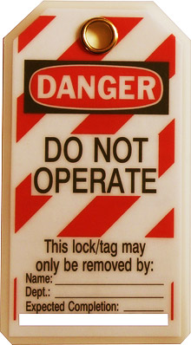
Employers must create a lockout/tagout program if employees work with machinery, and employees must learn and follow the program to keep themselves and others safe.
The Importance of Lockout/Tagout
Lockout/tagout procedures prevent the unexpected startup or release of energy from machines and equipment during servicing or maintenance. Employees face severe injuries, such as amputations, fractures, or even death if this hazardous energy is not controlled.
Roles
- Affected employees, whose jobs require them to operate or use machines or equipment that need servicing or maintenance and are in the lockout/tagout program
- Authorized employees, who perform lockout/tagout to perform servicing or maintenance
- Other employees, who work in the area where maintenance is being performed
Energy Sources Needing Control
- Electrical energy is the most common energy type.
- Mechanical energy is created by mechanical movement.
- Chemical energy is produced by chemical reactions.
- Hydraulic energy is derived from the motion and pressure of liquids.
- Pneumatic energy is the product of stored pressure from gas or air within pneumatic lines and vessels.
- Potential energy is stored energy that can be hazardous if released.
This form documents that the training specified above was presented to the listed participants. By signing below, each participant acknowledges receiving this training.

Organization: Date:

Trainer: Trainer’s Signature:

Class Participants:

Name: Signature:

Name: Signature:

Name: Signature:

Name: Signature:

Name: Signature:

Name: Signature:

Name: Signature:

Name: Signature:

Name: Signature:

Name: Signature:

Name: Signature:

Name: Signature:

Name: Signature:

Name: Signature:

Name: Signature:

Name: Signature:

