Warehousing Safety
Training Short 2.0

Warehouse operations keep goods and services moving throughout the world. However, employees in these busy and active workplaces face a wide variety of potential hazards. Common warehouse safety issues involve forklift operations, ergonomic hazards, chemical safety concerns, slip and fall risks, heat illness exposures, and emergencies.

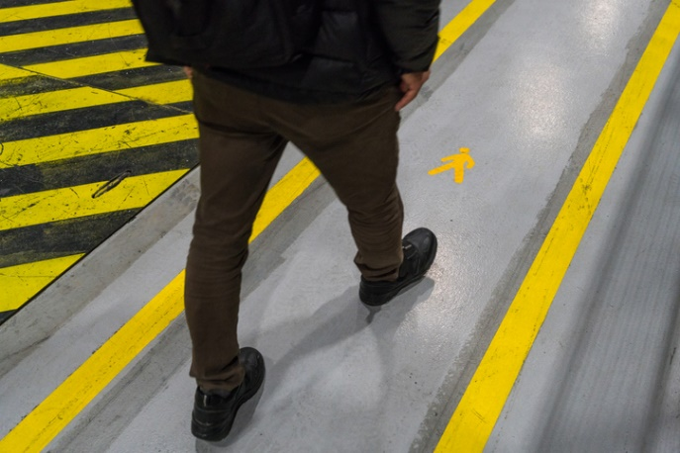
General Warehouse Safety
Follow these general safety rules:
- No horseplay! The warehouse is full of moving vehicles, equipment, and heavy loads. Accidents can happen in the blink of an eye.
- Wear appropriate shoes with good tread. Refer to your facility’s personal protective equipment requirements for specifics.
- Stay in designated walkways and keep aisles and exit paths clear.
- Clean up all spills as they occur.
Stay in designated walkways to avoid contact with forklifts or other equipment.
- Use appropriate ladders! Never stand on crates, boxes, pallets, or other unstable surfaces.
- Maintain adequate facility lighting. Report any burnt-out lighting to your supervisor.

Materials Handling
Improperly stored materials may fall and injure people. Improperly using equipment or lifting heavy objects can also cause injuries due to unsafe material handling. Ensure that you:
- Position your body properly during lifting and loading so that you won’t become caught or pinned between objects.
- Stack loads evenly and straight. Place heavier loads on lower or middle shelves.
- Remove one object at a time from shelves.
- Never carry a load in a way that obstructs your vision.
- Remove damaged pallets from service, as compromised pallets can cause unstable loads.
- Pay special care to all necessary handling and storage precautions when handling hazardous materials.

Tip: Help prevent overloading by posting and maintaining load capacity limits on all load-lifting equipment, shelving, storage racks, and storage areas,

Ergonomics
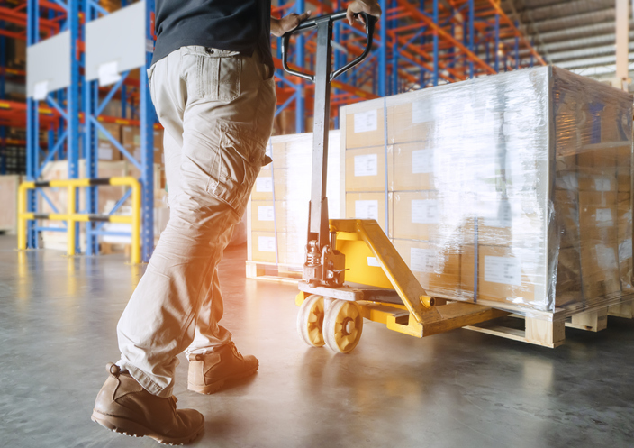
Improper lifting, repetitive motion, or poor operational design can lead to musculoskeletal disorders. Common signs of musculoskeletal disorders include achiness or stiffness, muscle twitching, muscle burning, and pain that worsens with movement. In addition to receiving training on safe ergonomics for your specific tasks, you can do the following to help avoid injury:
- Use lifting equipment instead of a manual lift for heavy materials.
- Reduce lifts from shoulder height and floor height by repositioning the shelf or bin.
- Practice good lifting techniques and prepare your body for movement with stretches.
Pallet jacks, hand trucks, and other lifting equipment helps reduce lifting strain in areas where forklifts are unable to go.
- Use anti-fatigue or comfort mats on hard floors and other hard contact surfaces.
- Where possible, use work-rest cycles to allow time to recover from repetitive or strenuous movements.

Forklift & Other Powered Industrial Truck Use
Forklifts, order pickers, and other powered industrial trucks reduce manual material handling in warehouse facilities. However, only trained and certified operators aged 18 or older may use these machines. Forklift accidents injure thousands of employees every year. Here are some ways to prevent these injuries:

- Before each use of a powered industrial truck, complete an equipment inspection. If any deficiencies are found, report them to a supervisor and remove the equipment from service.
- Follow safe procedures for picking up, putting down, and stacking loads.
- Respect boundaries – forklifts should stay out of pedestrian areas, and pedestrians should stay out of designated forklift areas.
- Drive safely. Use extra caution in congested areas or on slick surfaces.
- Never drive up to a person standing in front of a fixed object, such as a wall or stacked materials.
- Ensure adequate ventilation to reduce the buildup of engine exhaust.
- If using a stand-up forklift, be aware of under-ride hazards. These can occur if the forks are trailing when backing up, as the operator can become caught under storage racks or other equipment. Use a stand-up forklift with a cage, reposition shelving, or install guards or barriers at the base of the shelving to prevent under-ride hazards.

Working Safely at Loading Docks
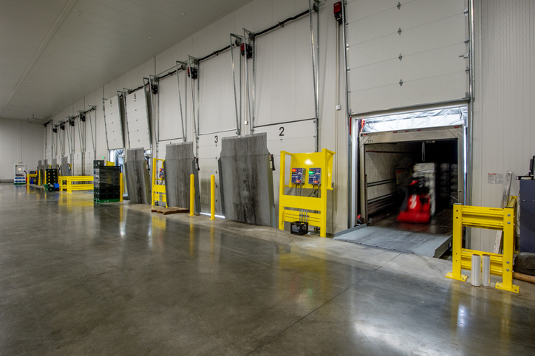
Injuries can occur when forklifts drive off the dock, products or materials fall on employees, or a piece of equipment strikes a person. To avoid these injuries:
- Drive forklifts slowly on docks and dock plates.
- Secure dock plates and check to see if the plate can safely support the load.
- Be aware of dock edges and never back up forklifts to the edge.
- Maintain communication with the forklift operator if you are assisting in the area.
- Observe visual warnings near dock edges.
- Do not jump between different docks.
Loading docks can easily become congested. Be alert and stay aware of equipment.
- Never use a forklift to close a dock door.

Heat Illness Prevention
Heat illnesses refer to serious and potentially life-threatening medical conditions that happen when a person’s body is unable to cope with excessive heat. Both outdoor and indoor work environments may have hot conditions. As a result, workers may experience heat-related health problems. Follow your facility’s heat illness prevention procedures, including:
- Know the early signs and symptoms of heat illness – cramps, headache, sweating, nausea, rapid pulse, and red skin.
- Understand your own personal risk of heat illness as it can differ from others. This is especially true for those who have had previous heat illnesses, have heart conditions, or are pregnant.
- Heat stroke is a medical emergency, and the victim requires immediate attention. During heat stroke, a victim may have lost consciousness, is no longer sweating, and may be convulsing, vomiting, or extremely dizzy.
- Take rest and water breaks as needed when temperatures rise.
- Allow your body to acclimate to working in hot weather – this may take up to 14 days.

Walking & Working Surfaces

Warehouse flooring is subject to constant use from forklifts, equipment, and foot traffic. It’s important to keep flooring and surfaces clear and to inspect work areas regularly to fix any damaged or
worn surfaces.
- Avoid running extension cords, hoses, or other trip hazards across walkways or exits. If they must be used, use a protective covering device with high visibility.
- Keep wet floor signs readily available, especially near doorways, loading docks, or other areas with weather exposure.
- Check your shoes for debris, residue, or other materials that you may track with you throughout the facility. This may reduce your traction on certain surfaces and cause a slip hazard.
- If using carpets or mats, keep them flat on the floor and check for upturned edges.
- Use drip trays, dust collectors, or other collection devices to keep floors clean.

Hazard Communication
Chemical spills or leaks may expose you to hazardous substances. Such spills or leaks may result in eye injuries, skin burns, or inhalation injuries. You must be trained on the hazards of each chemical being stored at your facility and have access to the safety data sheet (SDS) for all the chemicals you work with. Remember to:
- Review chemical hazards, safety instructions, and other chemical information on the SDS.
- Know the location of the spill cleanup kits wherever chemicals are stored.
- Know how to clean up spills, protect yourself, and properly dispose of used materials.
- Wear all required personal protective equipment (PPE).
- Store all chemicals safely and securely.
- Store chemicals away from forklift traffic areas.

Remember: If the spill is causing an immediate threat to safety and health, evacuate the area and call 911.

Emergency Preparedness
Organizations must have an emergency plan that describes what is expected of employees in the event of an emergency. Employees must understand the contents of this plan and what their role is in an emergency. Remember these elements:
- Know the exit routes in your work area. Keep the exit paths and exit doors clear and accessible at all times.
- Understand how to use a portable fire extinguisher. Remember to PASS – Pull, Aim, Squeeze, Sweep.
- Know the locations of your facility’s evacuation assembly points and shelter-in-place areas.
- In the event of a medical emergency, call 911. If your facility has a trained first aid responder, they should also be contacted.

Note: Report any unsafe conditions to your supervisor.

Warehousing Safety - Training Roster

This form documents that the training specified above was presented to the listed participants. By signing below, each participant acknowledges receiving training on the abovementioned subject. They understand that this training was only a general overview of the subject and that they should contact their supervisor with any questions or concerns.

Organization: ________________________ Date: _________________________________

Trainer: ___________________________ Trainer’s Signature: _____________________
Class Participants:

Name: _____________________________ Signature: ________________________________
Name: _____________________________ Signature: ________________________________
Name: _____________________________ Signature: ________________________________
Name: _____________________________ Signature: ________________________________
Name: _____________________________ Signature: ________________________________
Name: _____________________________ Signature: ________________________________
Name: _____________________________ Signature: ________________________________
Name: _____________________________ Signature: ________________________________
Name: _____________________________ Signature: ________________________________
Name: _____________________________ Signature: ________________________________
Name: _____________________________ Signature: ________________________________
Name: _____________________________ Signature: ________________________________
Name: _____________________________ Signature: ________________________________
Name: _____________________________ Signature: ________________________________
Name: _____________________________ Signature: ________________________________
Name: _____________________________ Signature: ________________________________
Name: _____________________________ Signature: ________________________________
Name: _____________________________ Signature: ________________________________

