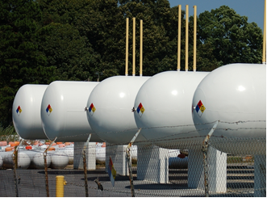
Propane is a liquid in its compressed state (inside of a cylinder) and becomes a gas when pressure is released. Propane is extremely flammable. Ignition sources are prohibited within 25 feet of the point of transfer. Other flammables or combustible materials are prohibited within 10 feet of the point of transfer. Review your local codes since more stringent requirements may apply to your facility.
Protection from vehicles:
- Propane tanks must be placed in an area away from vehicle traffic. Tanks installed where vehicle traffic is expected or is present need to be protected from potential impact.
- Propane tanks must be protected from vehicles. Use guard posts constructed of steel that are at least 4 inches in diameter and concrete filled. They should be spaced no more than 4 feet apart and set no less than 3 feet deep in a concrete footing that is 12 inches in diameter. The top of the post cannot be less than 3 feet above grade.
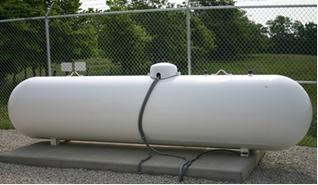
- A slight bump from a vehicle can be very damaging for propane tanks. If the force of the vehicle impact is too severe, the tank, fittings, or lines can leak and lead to a possible fire or explosion.
Protecting tank valves and fittings:
  - The propane tank dome protects it against damage to the tank’s fittings. The dome also provides protection for the regulator and its vent.
  - The tank dome must always be securely attached and closed.
Other safety considerations for propane tanks:
The propane tank dome protects the tank’s fittings from damage and must always be in place.
  - When installing tanks, pay attention to their location and ensure proper barriers are set up to prevent vehicles from damaging them.
  - Protect valves and fittings from environmental conditions, such as falling tree branches. You can accomplish by keeping the tank’s dome in place.
  - When dispensing is completed, close all of the storage tank’s valves. Place a dust cap or plug in the hose-end valve or filling adaptor.
  - Store the filler hose in its proper location after using it.
  - Close and lock the propane storage cabinet or fence gates when exiting a propane tank enclosure.
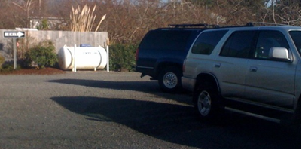

This propane tank does not meet the proper protection
requirements as it is not adequately protected from vehicles.

When storing propane tanks, be sure to pay attention to their placement relative to distance from important buildings and other structures. The table below shows minimum distance requirements in relation to the volume of propane being stored:

Container Capacity (in gallons) | Minimum Distances from Buildings (in feet) | Distance Between Containers (in feet)
Less than 125 gals | None | None
125-250 gals | 10 feet | None
251-500 gals | 10 feet | 3 feet
501-2,000 gals | 25 feet | 3 feet
2,001-30,000 gals | 50 feet | 5 feet
30,001-70,000 gals | 75 feet | ¼ of the sum of the diameters of adjacent containers
70,001-90,000 gals | 100 feet | ¼ of the sum of the diameters of adjacent containers

This form documents that the training specified above was presented to the listed participants. By signing below, each participant acknowledges receiving this training.

Organization: Date:

Trainer: Trainer’s Signature:

Class Participants:

Name: Signature:

Name: Signature:

Name: Signature:

Name: Signature:

Name: Signature:

Name: Signature:

Name: Signature:

Name: Signature:

Name: Signature:

Name: Signature:

Name: Signature:

Name: Signature:

Name: Signature:

Name: Signature:

Name: Signature:

Name: Signature:

