Objective: To assure that personnel involved in hurricane response and recovery operations are aware of common hazards and safe practices.

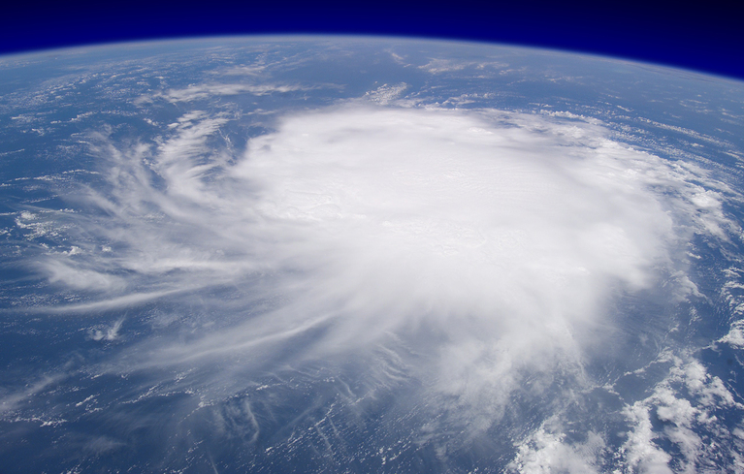
Hurricanes present several potential causes of severe damage, from rain and flooding to high winds and flying objects. Some of these conditions can persist after the storm has passed, so individuals left in its wake need to be familiar with precautions and hazards associated in recovery operations.

Worksite Evaluation and Exposure Monitoring:
Evaluate the site to identify any potential safety or health hazards.
- Prior to beginning work in hurricane areas, evaluate the site to identify any potential safety or health hazards and plan and employ appropriate controls to mitigate them.
- Certain tasks may require exposure monitoring, such as those involving work in areas with hazardous materials (e.g. lead, asbestos) or conditions (e.g. gases or fumes, noise). Assure that proper monitoring systems are in place before beginning work on these tasks.

General Safe Practices:
- Establish an evacuation plan, including safe evacuation routes and a system to alert individuals if evacuation is required.
- Assure that fire protection and suppression equipment is on site and in good working condition.
- Assure that first aid supplies and services are readily accessible for all employees.
General Safe Practices (continued):
- Maintain good hygiene habits, such as thoroughly washing hands with soap and clean water, alcohol-based sanitizers, or sanitizing wipes.
- Do not consume food or water that has been in contact with contaminated water or objects.
- Use sealable containers for trash or debris disposal.
- Avoid disturbing or creating dust and working upwind of dusty areas or activities when possible.

Common Hazards and Controls:
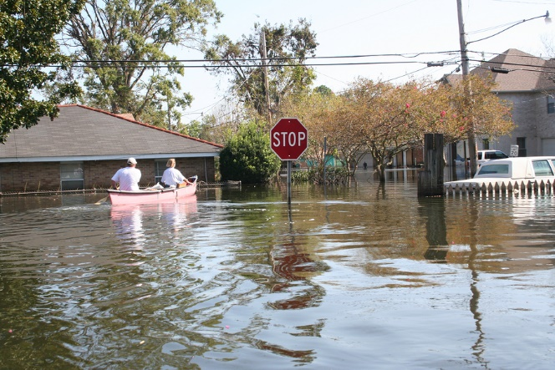
- Flooding: Hurricanes can be responsible for major flooding events, which can present numerous health and environmental dangers in addition to those caused by the hurricane. Familiarize yourself with common flooding hazards and take any extra precautions as necessary.
- Structural instability: A damaged building’s structural integrity may be difficult to determine at first glance, so have a competent person inspect a structure’s stability if access is necessary. Add temporary structural reinforcements and limit access to necessary personnel and areas.
- Downed power lines: Downed or damaged power lines may still be energized, so keep a safe distance from the lines and any structures, objects, or bodies of water they may be in contact with.

Common Hazards and Controls (continued):
- Slips, trips, and falls: Keep designated walkways or travel paths clear from tripping hazards or ledges, and cover or protect holes as they are discovered or created. If working at heights, limit access to trained personnel and use fall protection such as guardrails, safety nets, harnesses, or similar devices.
- Impact from flying objects: Use eye or face protection such as safety glasses, safety goggles, or face shields as appropriate.
- Manual or heavy lifting: Use safe lifting practices and take frequent breaks when dealing with heavy or water-laden objects.
- Discovery of unknown chemicals: Take defensive measures, such as moving to a safe distance upwind from the chemical’s source, and contact HAZMAT personnel for risk evaluation and removal of the chemicals. Re-evaluate PPE requirements as necessary.
- Cuts or lacerations: Take extra precaution when handling or working with or near sharp objects, and treat and bandage or cover any cuts or lacerations immediately.
- Personal hygiene: Maintain good hygiene habits, such as thoroughly washing hands with soap and clean water, alcohol-based sanitizers, or sanitizing wipes. Do not consume food or water that has been in contact with contaminated water or objects.
- Fatigue, heat, cold stress: Pay attention to signs of fatigue or stress caused by heat or cold. Allow for adequate rest, sleep, and meal breaks throughout the day.
- Contact with animals: Hurricane conditions can displace wild animals, such as snakes, alligators, or rodents, introducing them to populated areas. Pools of stagnant water can also be a breeding ground for disease-carrying insects such as mosquitoes. Take extra precaution if wild animals are discovered and do not handle without proper training, and use insect repellant or netting.

This form documents that the training specified above was presented to the listed participants. By signing below, each participant acknowledges receiving this training.

Organization: Date:

Trainer: Trainer’s Signature:

Class Participants:

Name: Signature:

Name: Signature:

Name: Signature:

Name: Signature:

Name: Signature:

Name: Signature:

Name: Signature:

Name: Signature:

Name: Signature:

Name: Signature:

Name: Signature:

Name: Signature:

Name: Signature:

Name: Signature:

Name: Signature:

Name: Signature:

