HOME OFFICE FIRE AND ELECTRICAL CONCERNS

When employees work from home, there is often little direction provided to support their safety. Assure the following are reviewed before employees start working from the home office to reduce the hazards associated with fires and electricity. Perhaps the greatest danger in the home is fire; not surprisingly, it represents an equal danger in the home office. Fortunately, there are several simple precautions that you can take to considerably reduce your fire risk.

These tips should be reviewed frequently to reduce and prevent fire hazards:

- Don’t overload electrical circuits and extension cords. If you have several pieces of office equipment running simultaneously, make sure that their combined voltage doesn’t exceed the capacity of their circuits. Extension cords are particularly prone to overload since they rarely feature the safety features of breakers or fuses.
- Check all electrical cords and plugs for damage and wear.
- Check to ensure electrical cords do not run under rugs and are never nailed or stapled in place.
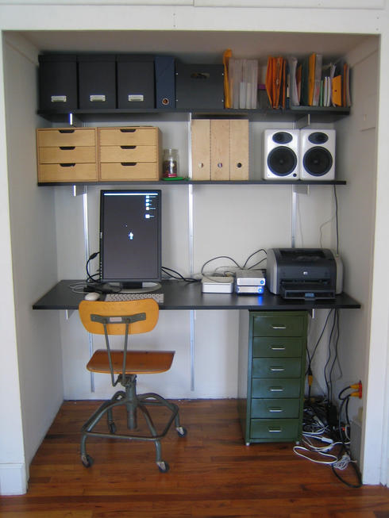
- Make sure extension cords are being used ONLY as a temporary measure.
- Ensure that extension cords and circuits are not overloaded.
- Make sure all electrical appliances are turned off when you leave the house.
- Complete regular backups of your data and store those backups offsite to reduce the consequence of electrical or computer failures, or fires destroying office equipment.
- Have a fire and evacuation plan. Have a fire escape route planned—a good idea for any home. Make sure that your office set-up doesn’t hinder escape. For instance, don’t place a large, difficult-to-move cabinet in front of the windows.
- Assure the plan is plan practiced regularly.
- Designate a meeting place where others can find you in case of fire.
- Have a fire proof filing cabinet or safe for documents and software disks.
- Assure there are unblocked exits for all areas.
- Know how to "stop, drop and roll" if your clothes catch fire.
- Remember that you should crawl low under smoke to safety in the event of fire and dense smoke.
- Regularly inspect the work area for fire hazards.
- Assure that your home has at least one smoke alarm on every level.
- Assure that the smoke alarms are tested regularly in accordance with the manufacturer's recommendations.
- Have a fire extinguisher handy. Choose one that is suitable for multiple types of fire, particularly paper and electrical fires.
- Know how to properly use the fire extinguisher that is provided.
- If you keep a hotplate or coffeepot in the office for convenience, keep paper and other flammable materials away from the hot surfaces. Be careful not to spill liquids on your computer, monitor, printer, etc.—liquids and electricity don’t mix!
- Turn off such appliances when not in use.
- If you use a space heater for warmth, choose one approved by Underwriters Laboratory (UL) for electrical safety. Keep it away from paper or other flammable materials, and turn it off when not in use. In general, space heaters are not recommended since they are responsible for many fires every year.
- Don’t get distracted by doing multiple tasks that involve fire risks, especially cooking in the kitchen while working.
- Don’t smoke. A stray cigarette or match can ignite paper, chemicals, or electrical equipment.
- As with the rest of your house or apartment, use common sense when dealing with fire hazards.

This form documents that the training specified above was presented to the listed participants. By signing below, each participant acknowledges receiving this training.

Organization: Date:

Trainer: Trainer’s Signature:

Class Participants:

Name: Signature:

Name: Signature:

Name: Signature:

Name: Signature:

Name: Signature:

Name: Signature:

Name: Signature:

Name: Signature:

Name: Signature:

Name: Signature:

Name: Signature:

Name: Signature:

Name: Signature:

Name: Signature:

Name: Signature:

Name: Signature:

