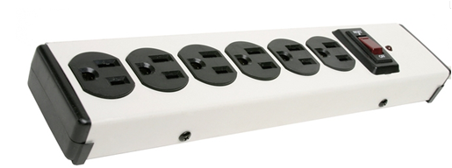
A power strip combines several sockets attached to the end of a flexible cable, allowing multiple devices to be plugged in. The biggest safety concern with power strips is their potential for fire if overloaded.
Precautions for fire prevention:
- Do not plug power strips into other power strips to make what is sometimes called a “piggy back” or “daisy chain.”
- Only use power strips that have a built-in surge protector (i.e., voltage regulator) and preferably also a built-in circuit breaker to prevent circuit overload.
- Do not use power strips for appliances with heating elements, such as electric space heaters or bench-top cooking appliances.
- Assure that all power strips meet recognized testing requirements. Although Underwriters Laboratories (UL) is the most recognizable label, there are many other testing laboratories that test and label electrical equipment.
- Do not plug power strips into extension cords; plug them directly into wall sockets. Extension cords are not to be used for permanent applications.
- A heavy reliance on power strips is an indication that you have too few outlets to address your needs. Have additional outlets professionally installed.
Determining power strip capacity:
Know the capacity of the circuit and the power requirements of all electrical items plugged into the power strip and other outlets on the circuit. In order to determine this:
- Determine the capacity of your power strip (in amps or watts).
- Determine the load (i.e. power requirements) of all the electrical items plugged into the power strip in amps or watts.
- Add up the power requirements. Assure that the total does not exceed 80% of the rated capacity of your power strip. Also, determine the same for the circuit serving the power strip to assure that it is not overloaded.
Example: A power strip is rated for 15 amps/120 V. (Note that watts = amps x volts.)
15 amps x 120 volts = 1800 watts.
1800 watts x 80% = 1440 watts that may be used.
Component | Computer | Monitor | Speakers | Electric Stapler | Scanner | TOTAL
Power Requirement | 250 watts | 150 watts | 15 watts | 25 watts | 150 watts | 590 watts

The power strip’s capacity of 1440 watts is not exceeded.
This form documents that the training specified above was presented to the listed participants. By signing below, each participant acknowledges receiving this training.

Organization: Date:

Trainer: Trainer’s Signature:

Class Participants:

Name: Signature:

Name: Signature:

Name: Signature:

Name: Signature:

Name: Signature:

Name: Signature:

Name: Signature:

Name: Signature:

Name: Signature:

Name: Signature:

Name: Signature:

Name: Signature:

Name: Signature:

Name: Signature:

Name: Signature:

Name: Signature:

