Objective: To inform employees about achieving neutral body posture at their workstation in order to avoid long term MSDs and to encourage healthy ergonomics

While there is no single posture or configuration that will work for everyone, keeping the principles of neutral body posture in mind while setting up your workstation and while working will increase your level of comfort and greatly reduce the risk of musculoskeletal disorders (MSDs).
Neutral body posture is a natural and comfortable position where joints, muscles, connective tissues such as tendons, and the skeletal system are aligned.
Posture Guidelines
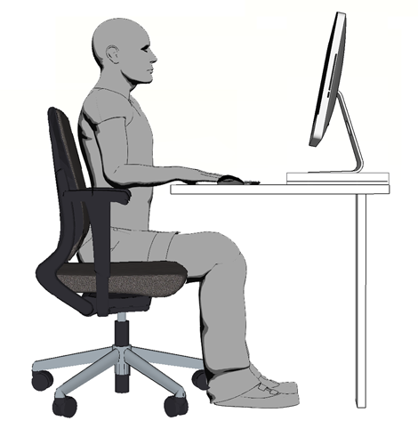
If standing, align your ears, shoulders, hips, knees, and ankles.
If sitting at a desk, adjust your seat, the computer monitor if applicable, and any articles you use in order to meet the following conditions:
- Your feet are flat on the floor.
- Your knees are bent at a 90° angle or greater.
- Your thighs are horizontal to the floor and at a right angle with your hips.
- Your arms and forearms are at right angles.
- Your wrists should be straight lines with your forearms, not bent vertically or horizontally.
- Your elbows should hang close to your body.
- Your shoulders should be relaxed.
- Your head should be in line with the torso or bent slightly forward, not tilted back or twisted to the side.
In addition to using neutral posture, break up tasks and stretch regularly.
This form documents that the training specified above was presented to the listed participants. By signing below, each participant acknowledges receiving this training.

Organization: Date:

Trainer: Trainer’s Signature:

Class Participants:

Name: Signature:

Name: Signature:

Name: Signature:

Name: Signature:

Name: Signature:

Name: Signature:

Name: Signature:

Name: Signature:

Name: Signature:

Name: Signature:

Name: Signature:

Name: Signature:

Name: Signature:

Name: Signature:

Name: Signature:

Name: Signature:

