Objective: To reinforce awareness of how to work safely with hand trucks.

Understanding Use
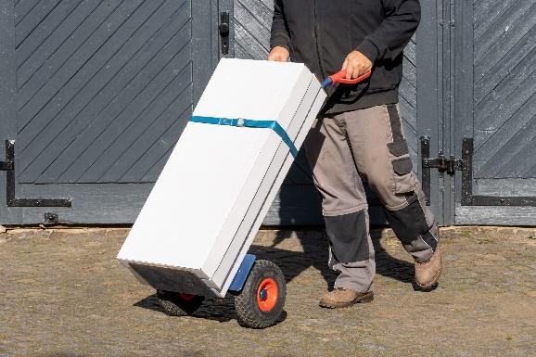
Hand trucks, dollies, and carts are effective for reducing strain while moving heavy materials. However, injury can still occur. Use the following tips to prevent strains, trips, or falls when using a hand truck.
Lifting Practices
- Know the load capacity for your hand truck! Don’t overload it.
- Load and unload the hand truck carefully, following proper
lifting techniques.
- Always use good ergonomic practices while lifting and loading items onto the hand truck.
- Get help if the load can’t be handled safely.
Before Moving a Load
- Inspect equipment before use. Check the uprights, crossbars, weld points, and tires.
There are a variety of hand truck sizes and styles to suit various lifting needs. Use the appropriate one for the load you
are handling!
- Check the tire pressure. Balloon-type tires are more prone to losing pressure, adding strain on the person pushing the hand truck.
- Prepare the path.
  - Inspect and clear your path for ease of movement.
  - Use ramps if the path has stairs or curbs.
  - Measure openings to be sure that there is enough space.
  - Clear the set point.
- Ensure that you have a good view of your path. The load should not be so tall that it obscures your vision.

- Put the heaviest part of the load on the bottom of the hand truck and watch for shifting loads during movement.
  - If you are moving equipment with drawers, doors, or other parts that could open during transport, secure them or remove them before you get started.
- Secure the load as needed and ensure that the straps are tight.

Proper Use
- Grip the hand truck firmly and use both hands to move the load.
- Walk facing forward with the hand truck in front of you, unless you are backing out of a tight space.
- Tilting a truck back enables you to push the load uphill more easily, but be aware that this shifts the hand truck’s weight.
Best Practices
- Ensure that you’re trained and authorized for the work.
- Wear any required personal protective equipment as outlined in your facility’s hazard assessment. For example, you may need gloves or safety shoes.
- Stay alert when you’re in busy loading and unloading areas. Watch out for pedestrian traffic, forklifts, and
other equipment!
- Secure your cart inside your vehicle to prevent it from shifting during transport.

This form documents that the training specified above was presented to the listed participants. By signing below, each participant acknowledges receiving this training.

Organization: Date:

Trainer: Trainer’s Signature:

Class Participants:

Name: Signature:

Name: Signature:

Name: Signature:

Name: Signature:

Name: Signature:

Name: Signature:

Name: Signature:

Name: Signature:

Name: Signature:

Name: Signature:

Name: Signature:

Name: Signature:

Name: Signature:

Name: Signature:

Name: Signature:

Name: Signature:

Name: Signature:

Name: Signature:

Name: Signature:

Name: Signature:

Name: Signature:

