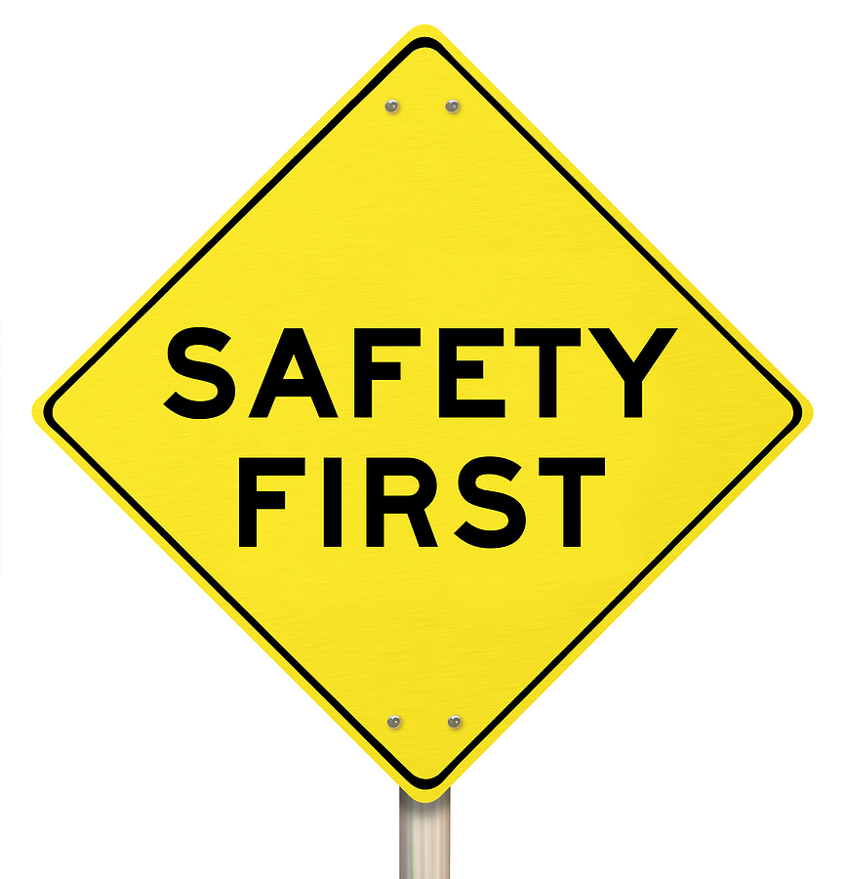
There is currently a war for talent. As a manager or supervisor, one of your most important roles is retaining talented employees. Experts agree: one of the best ways to win the talent war is to recognize your best employees and coach all your employees to perform better in all aspects of their jobs.

Many organizations are weak in this area: Managers can often view feedback, especially about safety performance, as unnecessary, time-intensive or negative, and so they avoid it. They assume that employees are doing what they can, and thus don’t encourage improvement.

Here are some quick tips for engaging the work group, raising safety performance, productivity and morale, as well as becoming a better coach:
Provide regular feedback:
- Don’t wait for formal review time to talk to employees about safety performance or their productivity.
- Most employees say they don’t get enough performance-related feedback.
- Schedule a regular time to meet with each employee, typically between once a week and once a month.

Address unsafe behaviors and poor work performance when you see it.
- Failure to address unsafe or unproductive behaviors perpetuates performance problems and forces other employees to accept or compensate for poor-performing team members.
- This can drain your team and increase potential problems.
- It is vital to tell employees who are working in an unsafe manner or those who are not meeting expectations that they are falling short of the requirements of the job.
- Remind them of the specific consequences that will arise if there is not improvement in their performance.

Differentiate among employees:
- Not all employees have the same knowledge, skill or ability or performance level.
- Provide specific guidance and coaching based on each individual’s performance.
- Recognize in a work group that anyone not working safely can create risk for others!

Recognize safety performers:
- Give positive feedback for safe work performance.
- Recognizing talented employees may encourage others to improve their performance, and make employees working safely feel appreciated for their efforts. There are many documented studies indicating that positive recognition is very beneficial, especially when it comes to safety performance.
- Feedback and recognition can elevate your workforce to new levels of safety performance and productivity and at the same time, help retain your best staff members.


Implementing these tips will help set your organization apart by coaching
employees toward safer performance and higher levels of productivity.

This form documents that the training specified above was presented to the listed participants. By signing below, each participant acknowledges receiving this training.

Organization:

Trainer: Trainer’s Signature:

Class Participants:

Name: Signature: Date:

Name: Signature: Date:

Name: Signature: Date:

Name: Signature: Date:

Name: Signature: Date:

Name: Signature: Date:

Name: Signature: Date:

Name: Signature: Date:

Name: Signature: Date:

Name: Signature: Date:

Name: Signature: Date:

Name: Signature: Date:

Name: Signature: Date:

Name: Signature: Date:

Name: Signature: Date:

Name: Signature: Date:

Name: Signature: Date:

Remember to load your completed trainings into the Risk Management Center.

